**SECTION 12)AWS CICD: CODE COMMIT,CODE BUILD,CODE PIPELINE, CODE DEPLOY**

**Requirement : we want to deploy code automatically**

**Introduction to cicd**

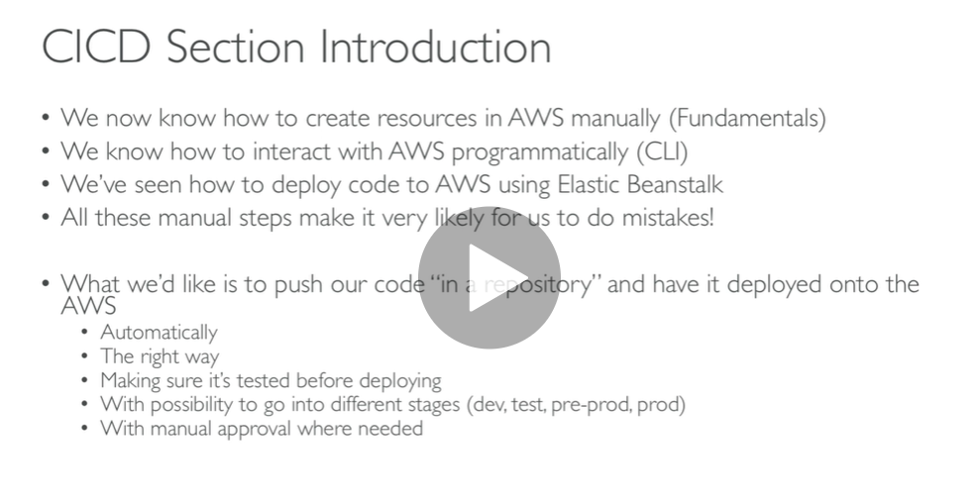

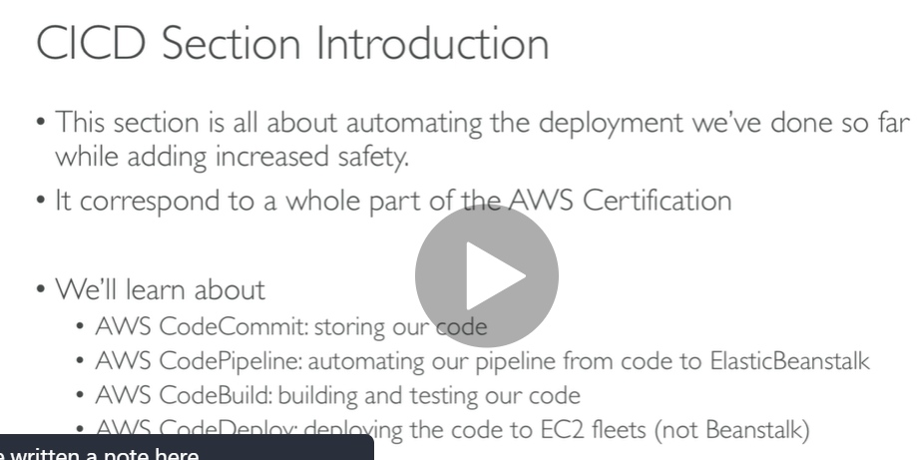

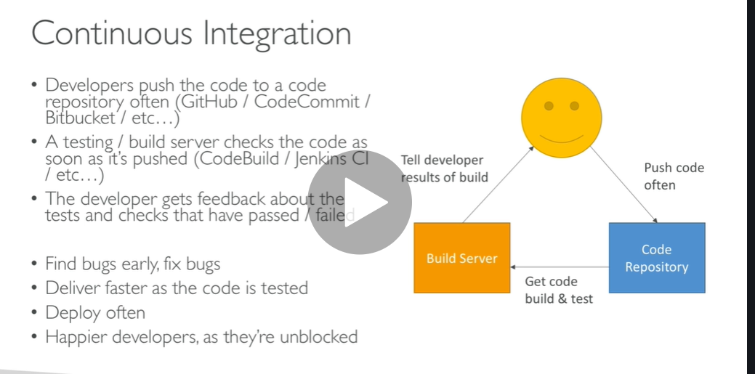

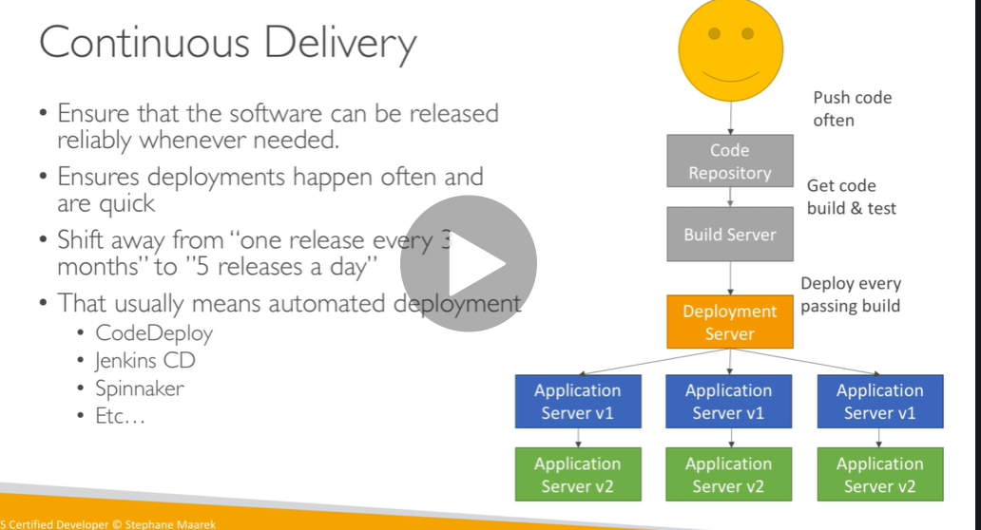

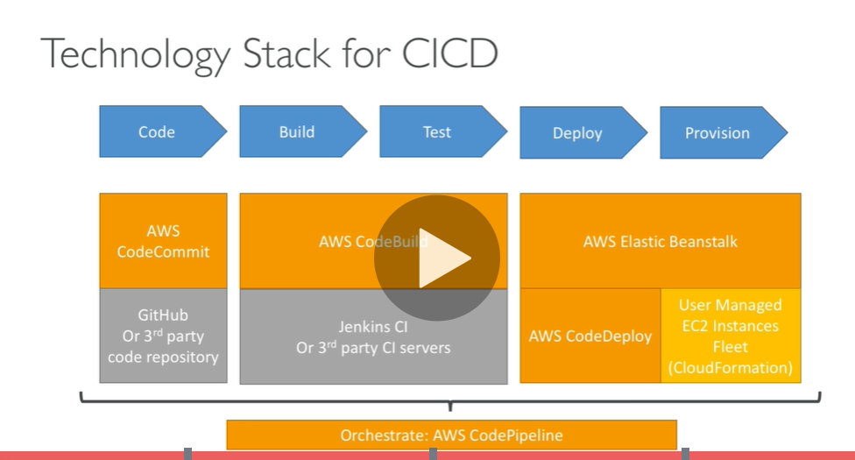

**Code commit overview**

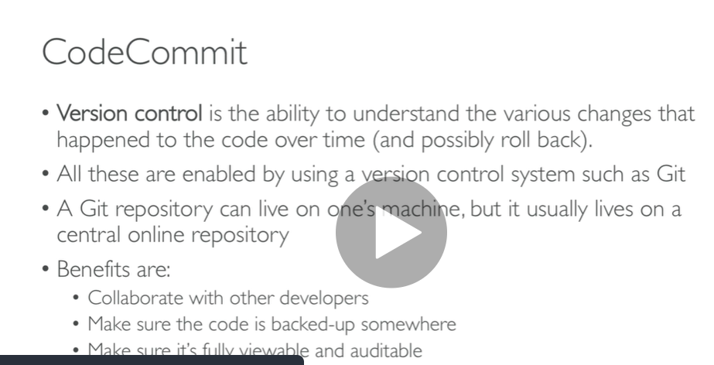

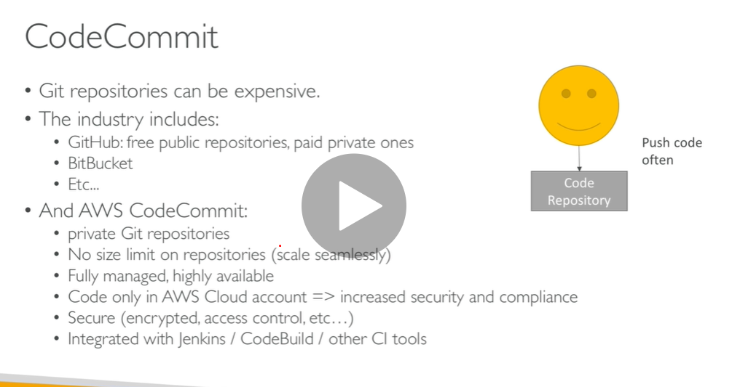

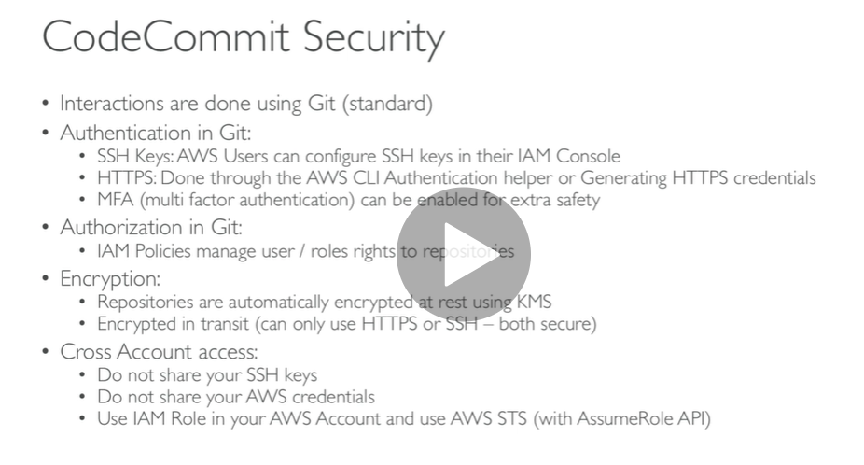

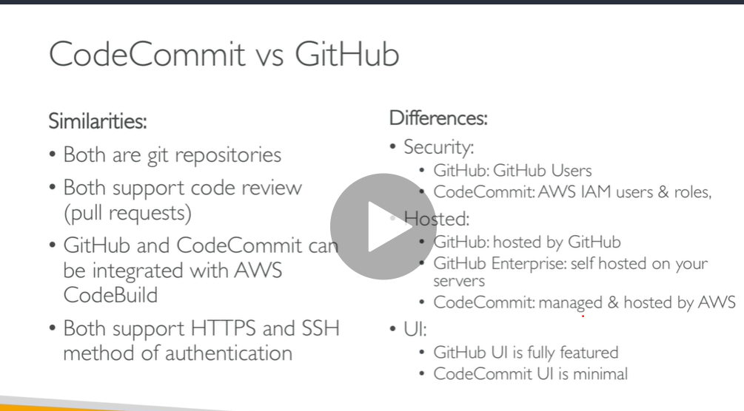

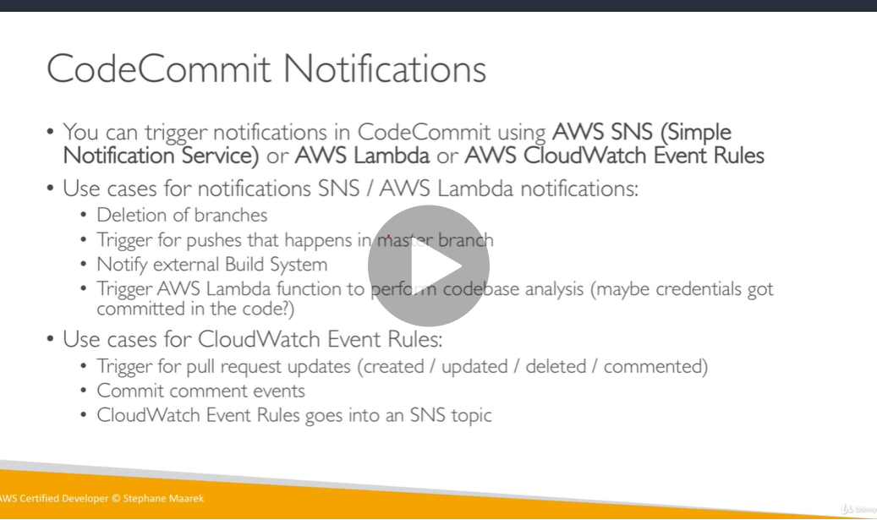

**Code commit hands on part 1**

**Step1**

Search code commit in service

Note in codecommit ( **code commit , code deploy , code pipeline ,code deploy**) all we see in one ui

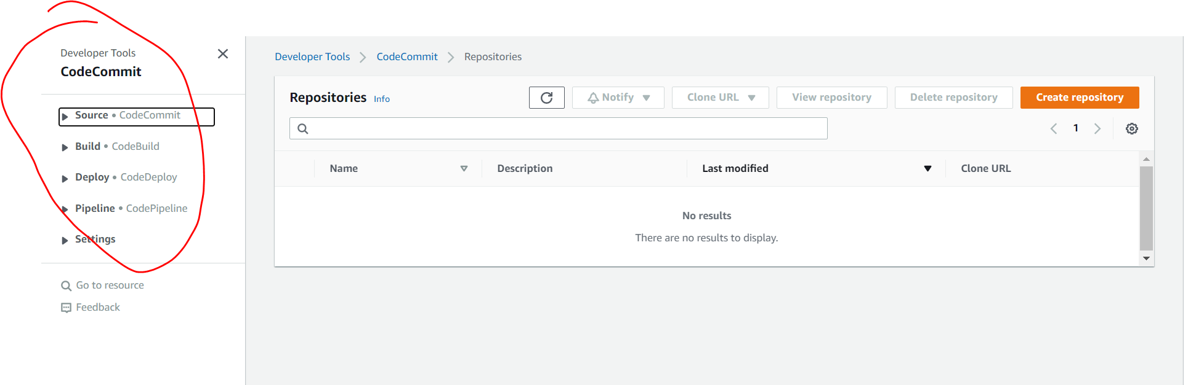

**Create repository**

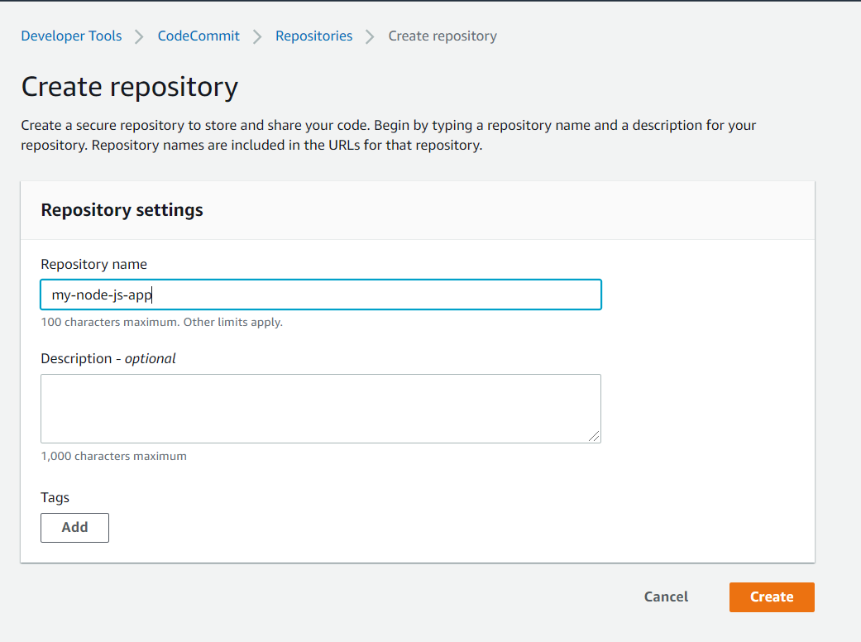

**Click create**

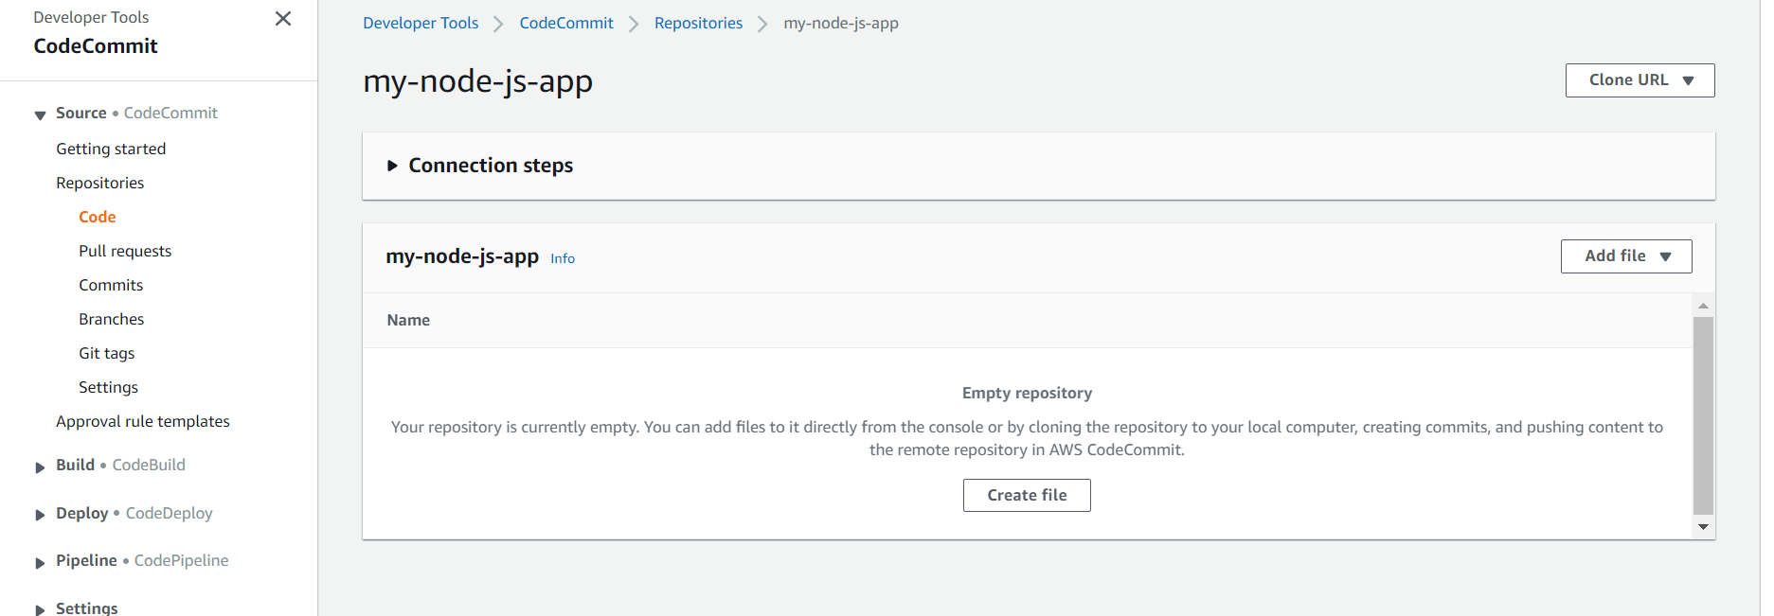

**Add file and upload index.html**

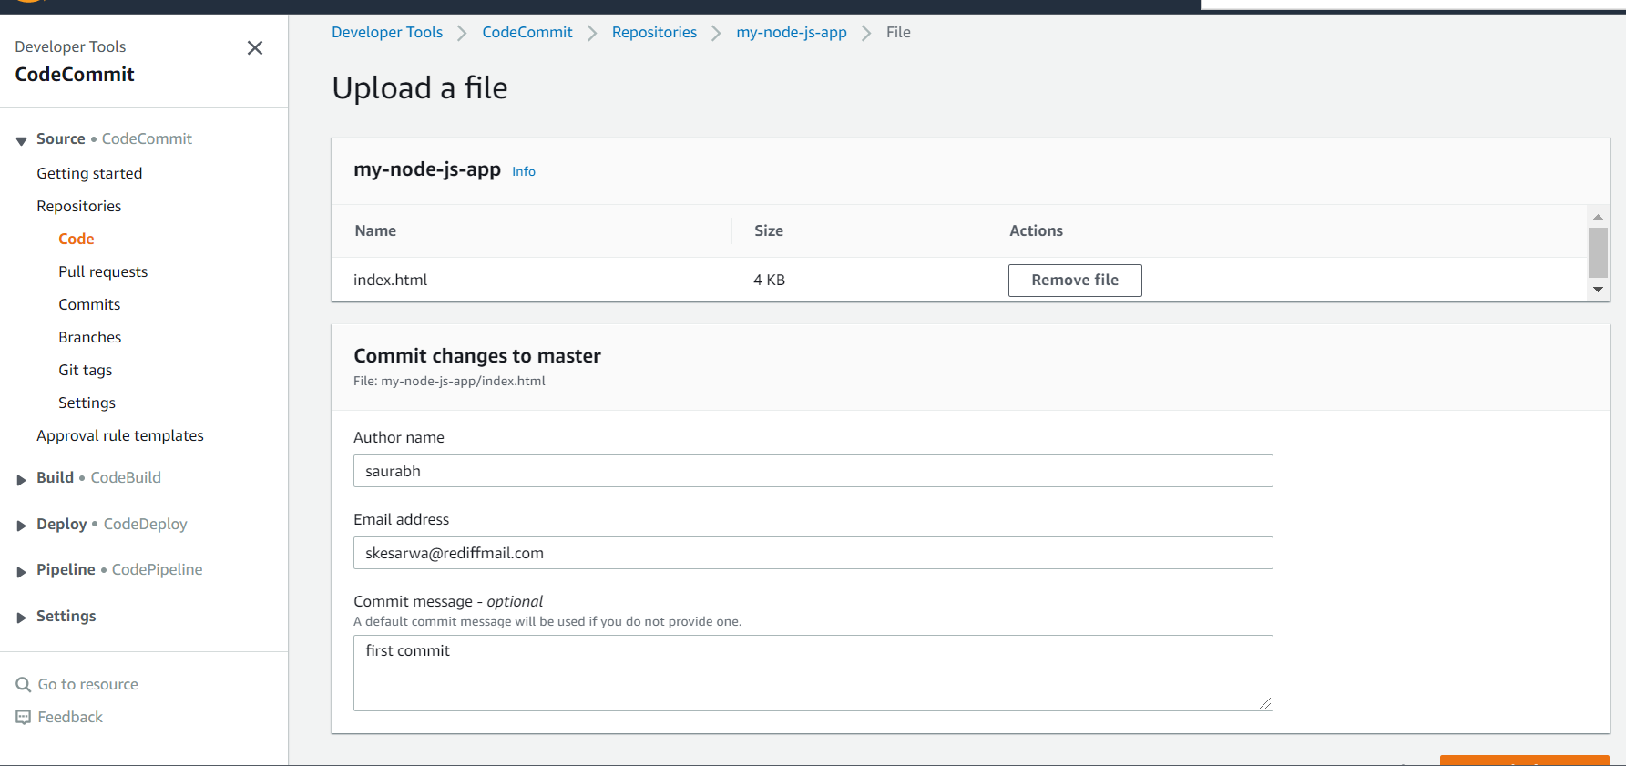

**This is first code commit and it occur in master**

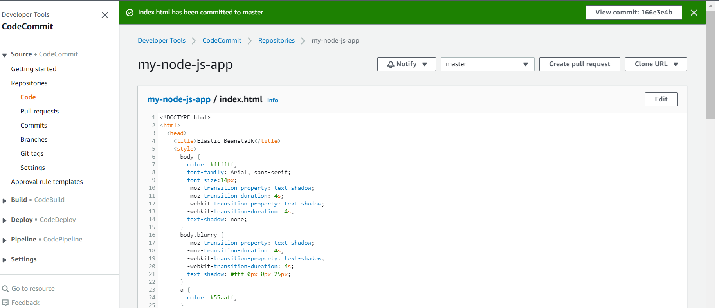

**We can see commit**

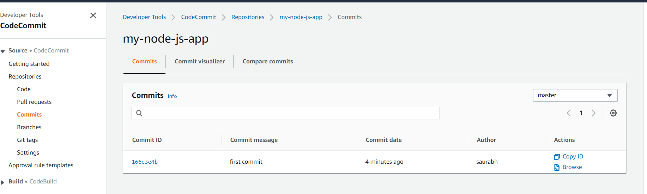

**Note : we can also compare commit from two different branch**

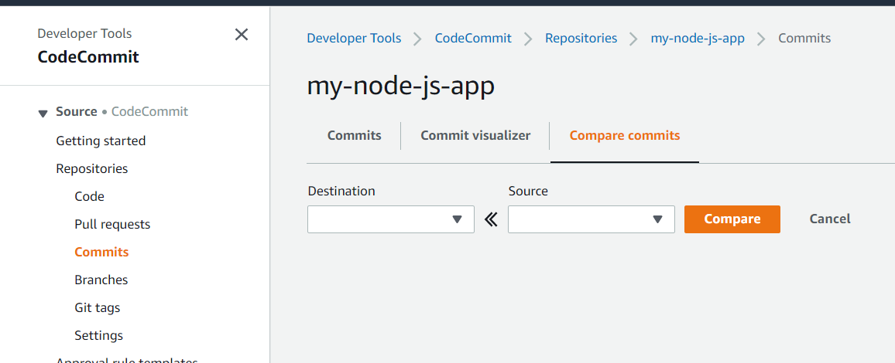

**Note : currently it is master we can create another branch**

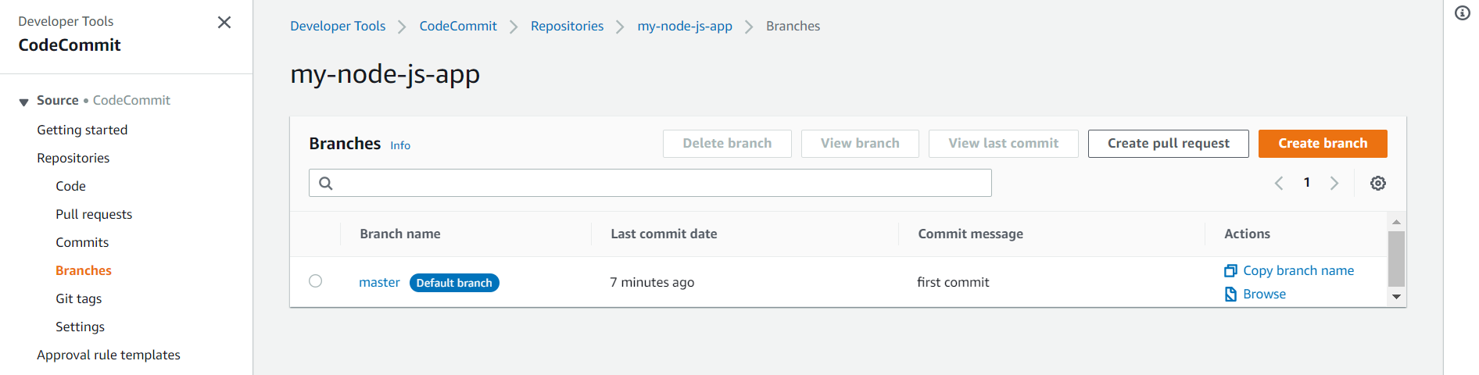

**Create notification rule for our repository**

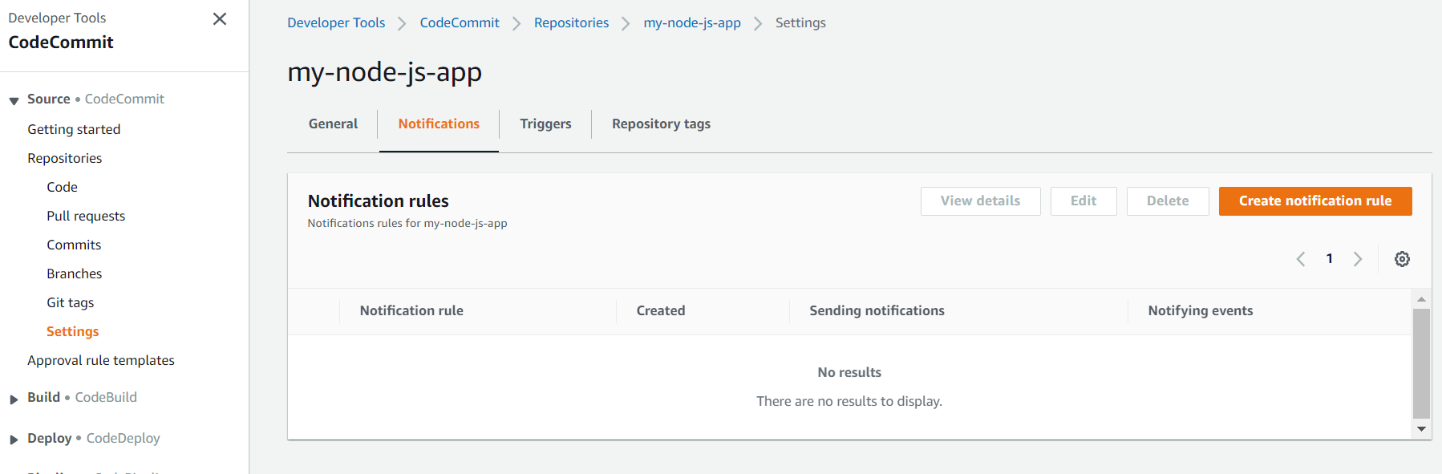

**These represent some changes happens on code commit repository**

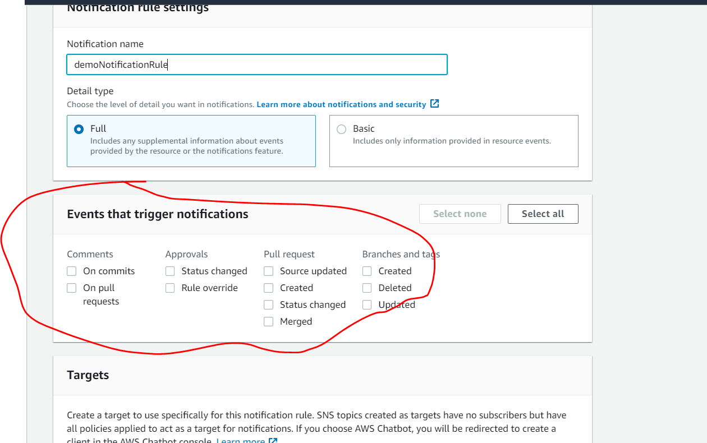

**We can create target**

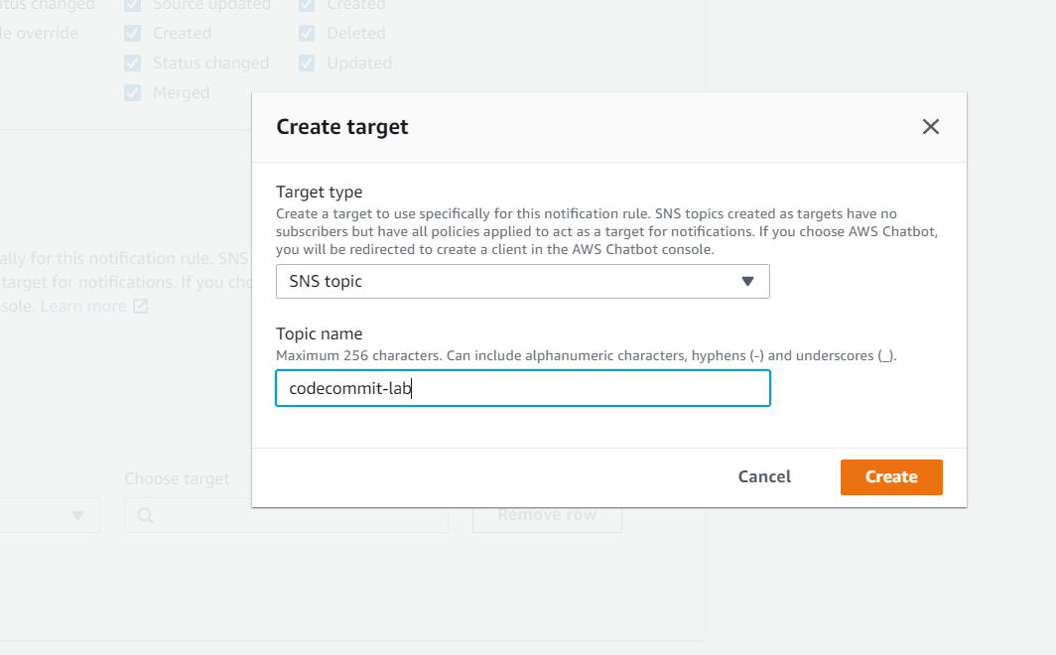

**Whenever any code commit happen sns topic will be notified and help us to trigger notification or email etc**

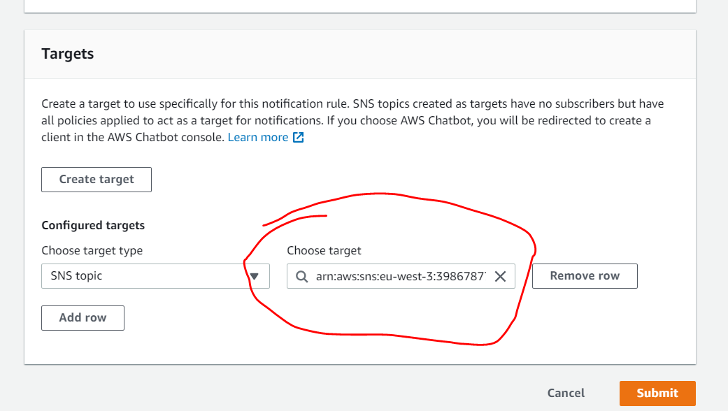

**Notification rule created**

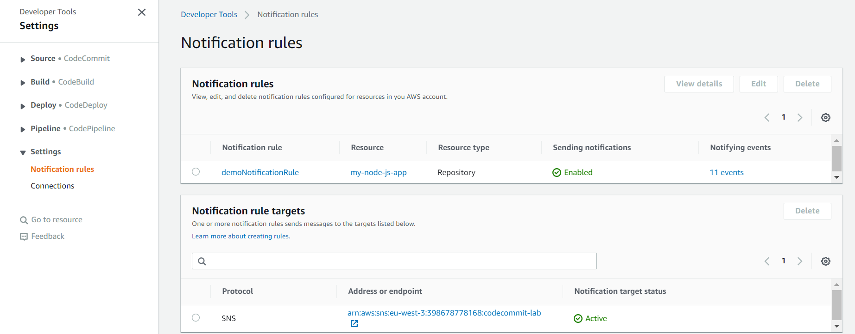

**Note :**

**We can create trigger basically for push to**

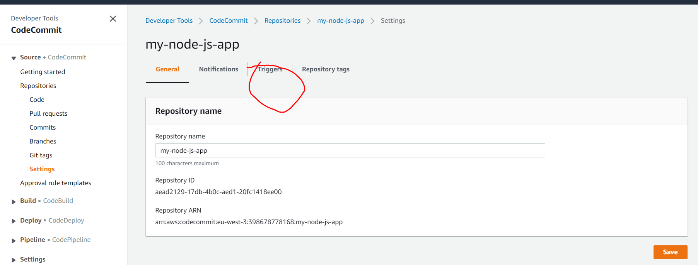

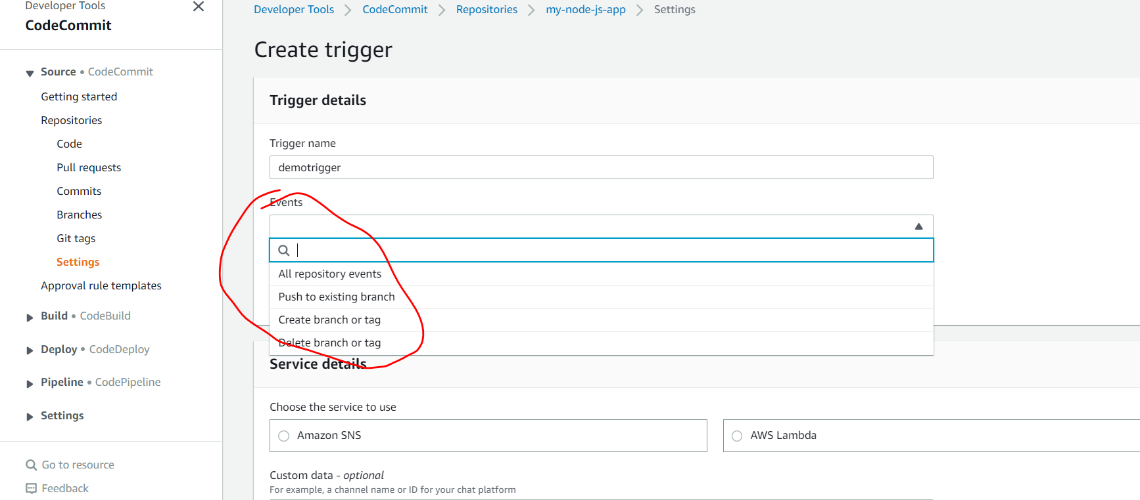

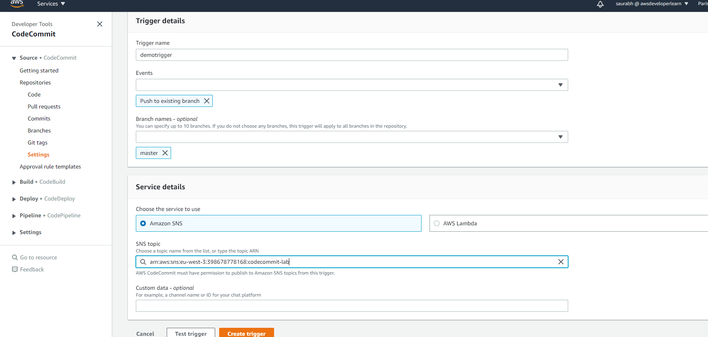

**That will send notification to SNS whenever code push happen to repository**

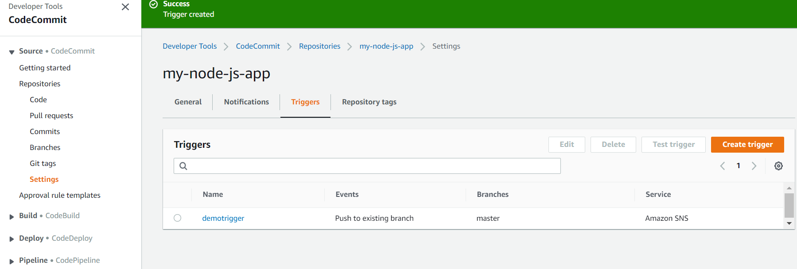

**Code commit hands on part2**

**Push file directly to code commit without uploading file**

**Go to iam users/security credential**

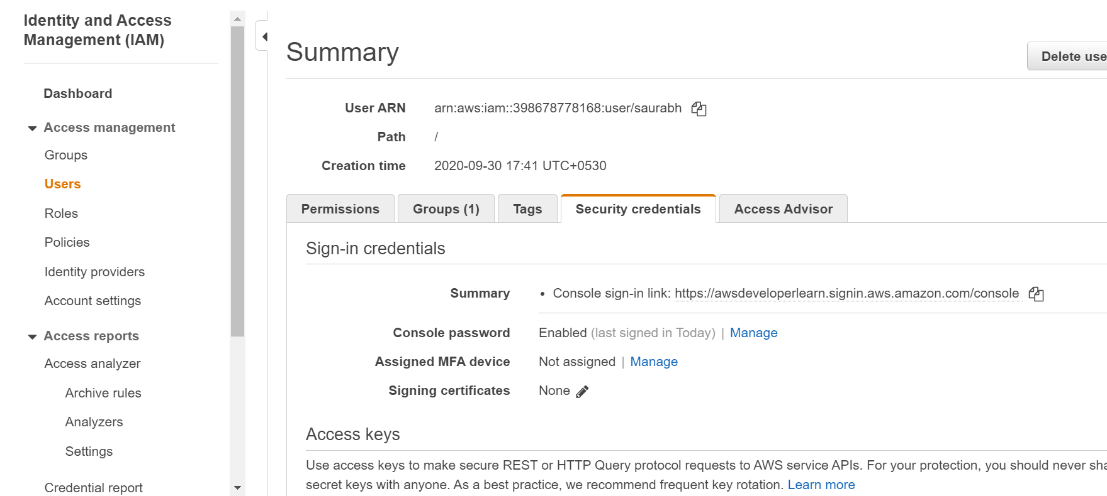

**NOTE: for code commit both ssh key and https are supported**

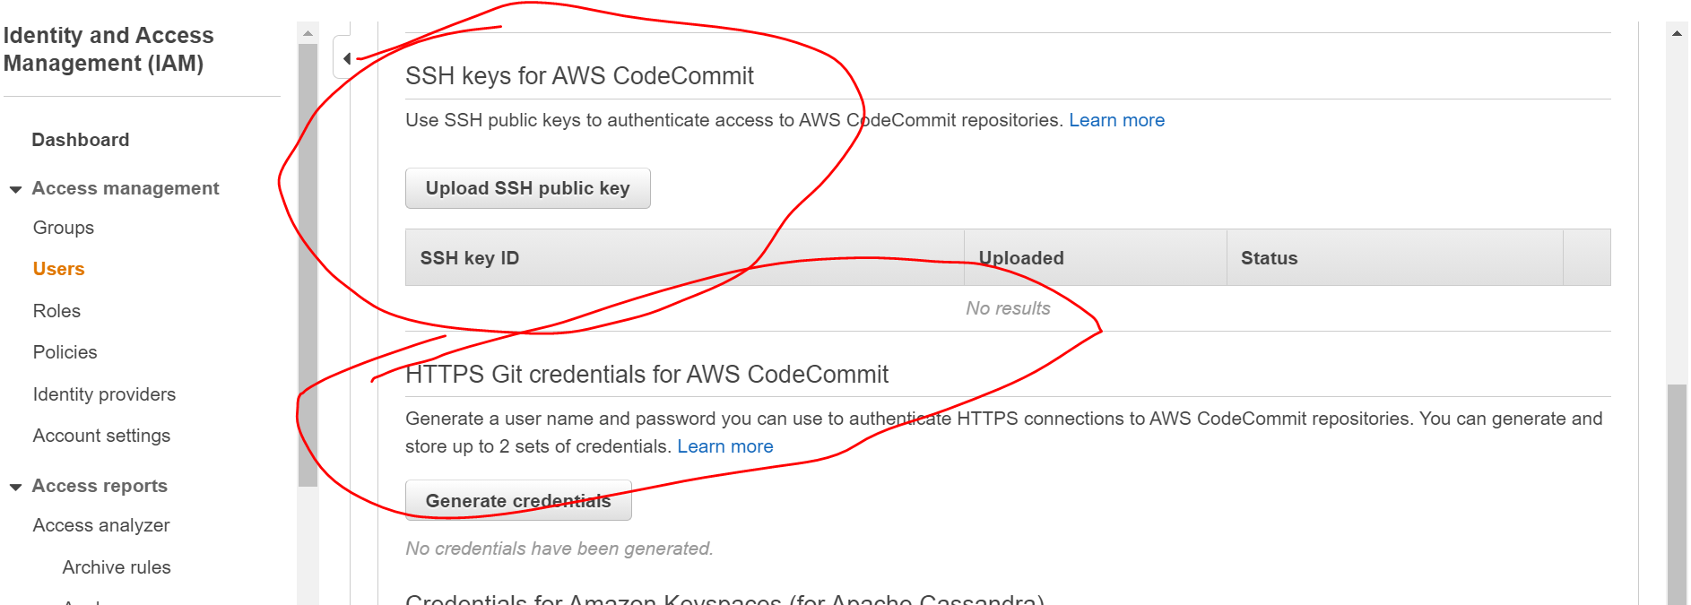

**Once we generate credential then it will become active**

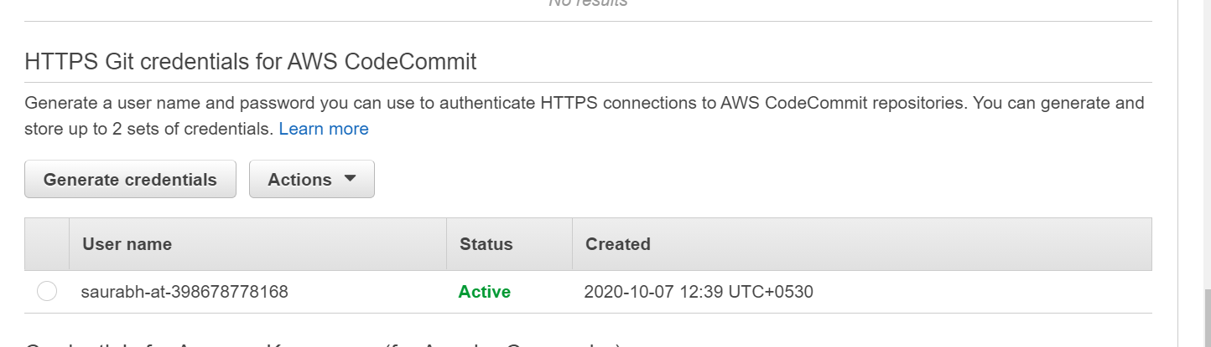

**This is a git connectivity to aws code commit by enabling https for user in iam/user/security**

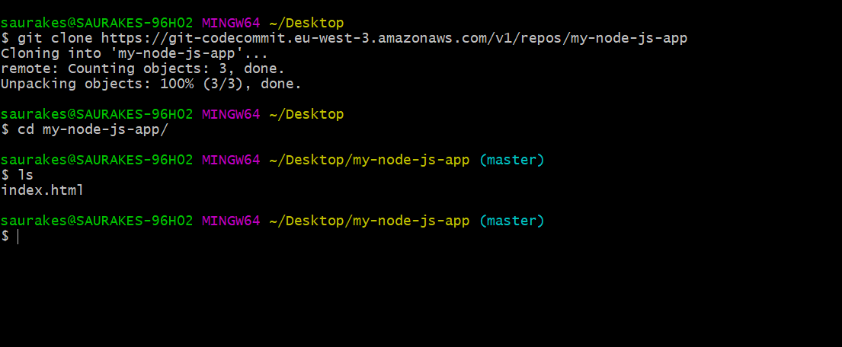

**Copy command**

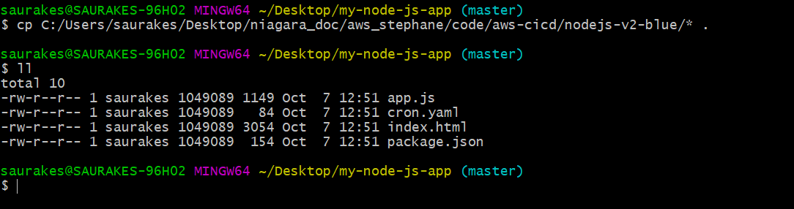

**After commit file from git**

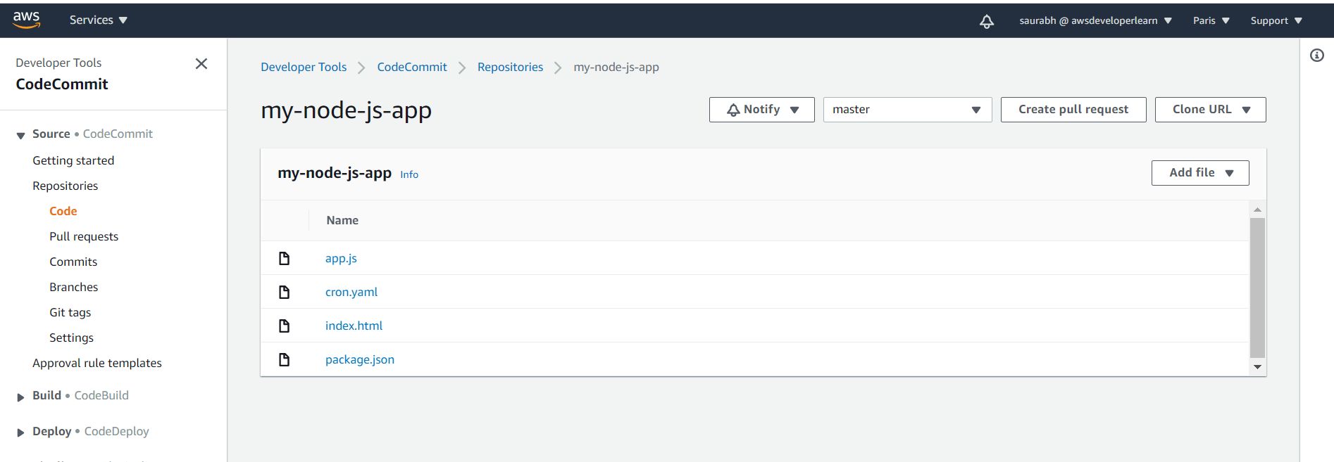

**Code pipeline overview**

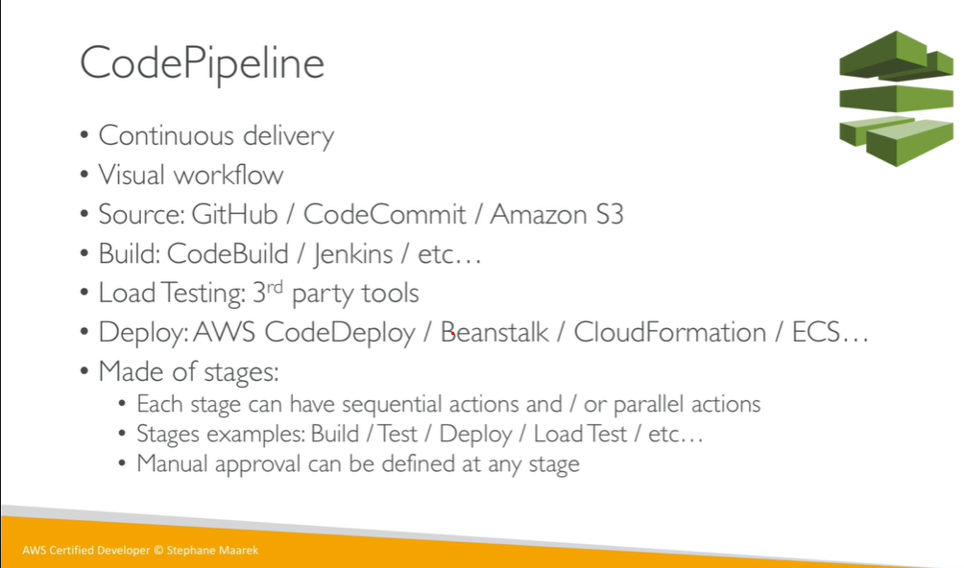

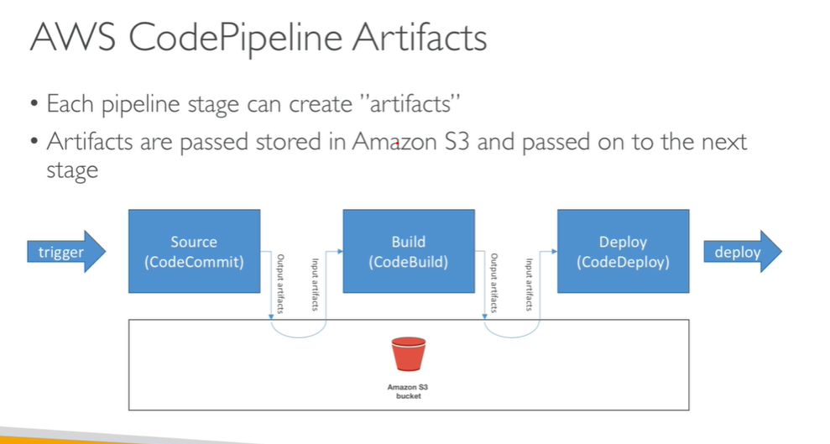

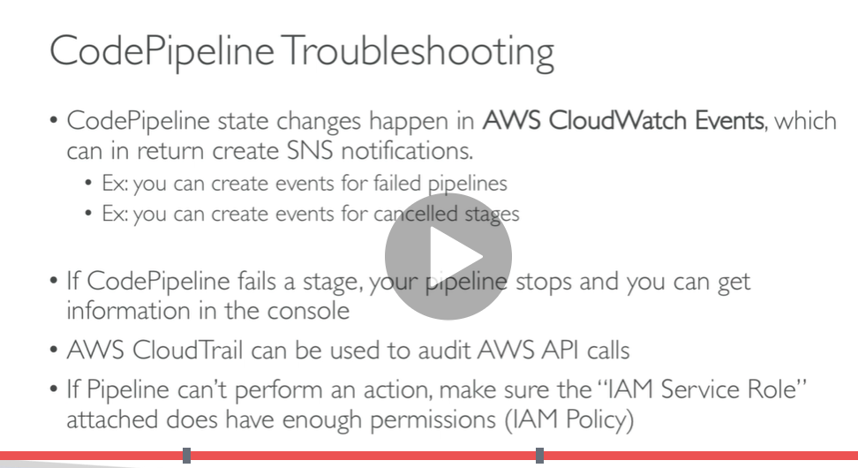

**Code pipeline hands on**

**Step 1) create pipeline**

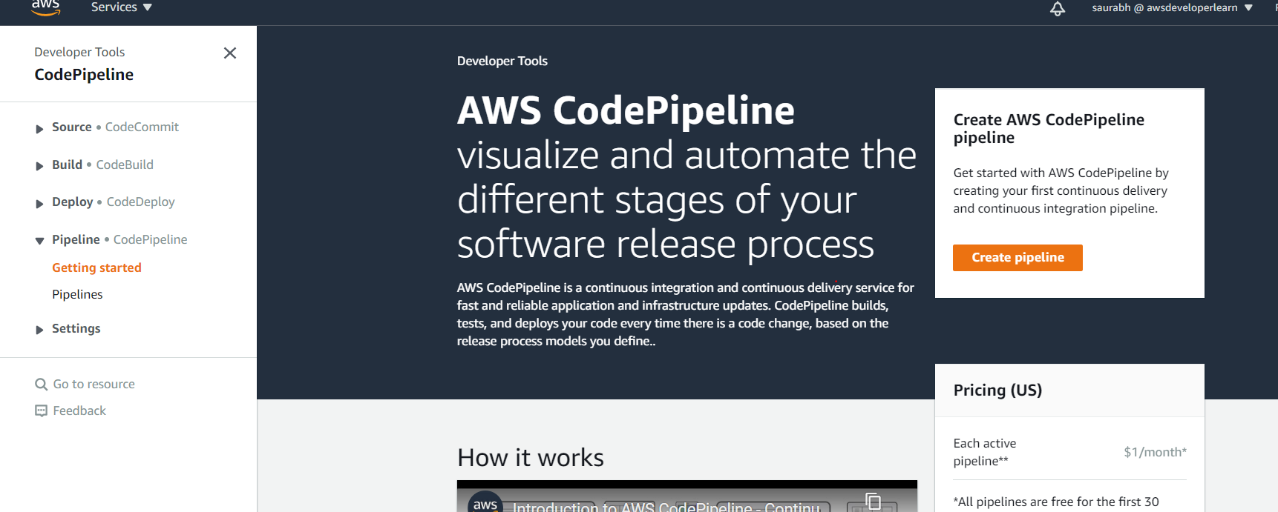

**Note :**

**Code pipeline allow to link sources, build and deploy stages**

**Note pipeline do a lot of thing : will talk to s3,code commit, beanstalk**

**We need to create service role that have permission to do**

**Using pipeline we can take code and deploy it( very important)**

**To run this create elastic beanstalk env to link with pipeline**

**Step 1:) create pipeline**

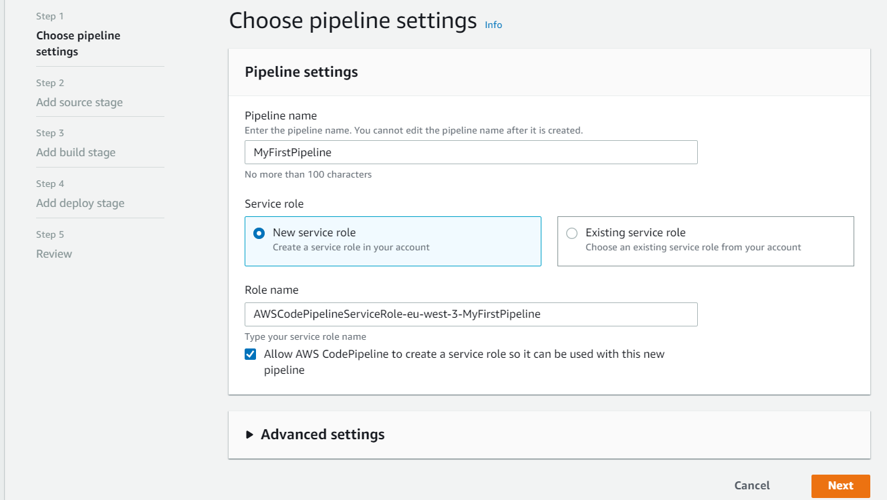

**Note: we can integrate any**

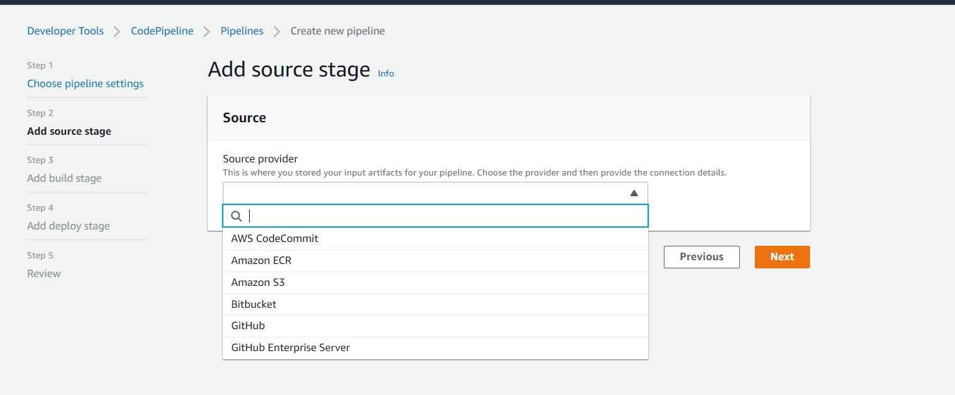

**step 2) But as of now lets go for code commit**

**Two ways code commit can be tracked**

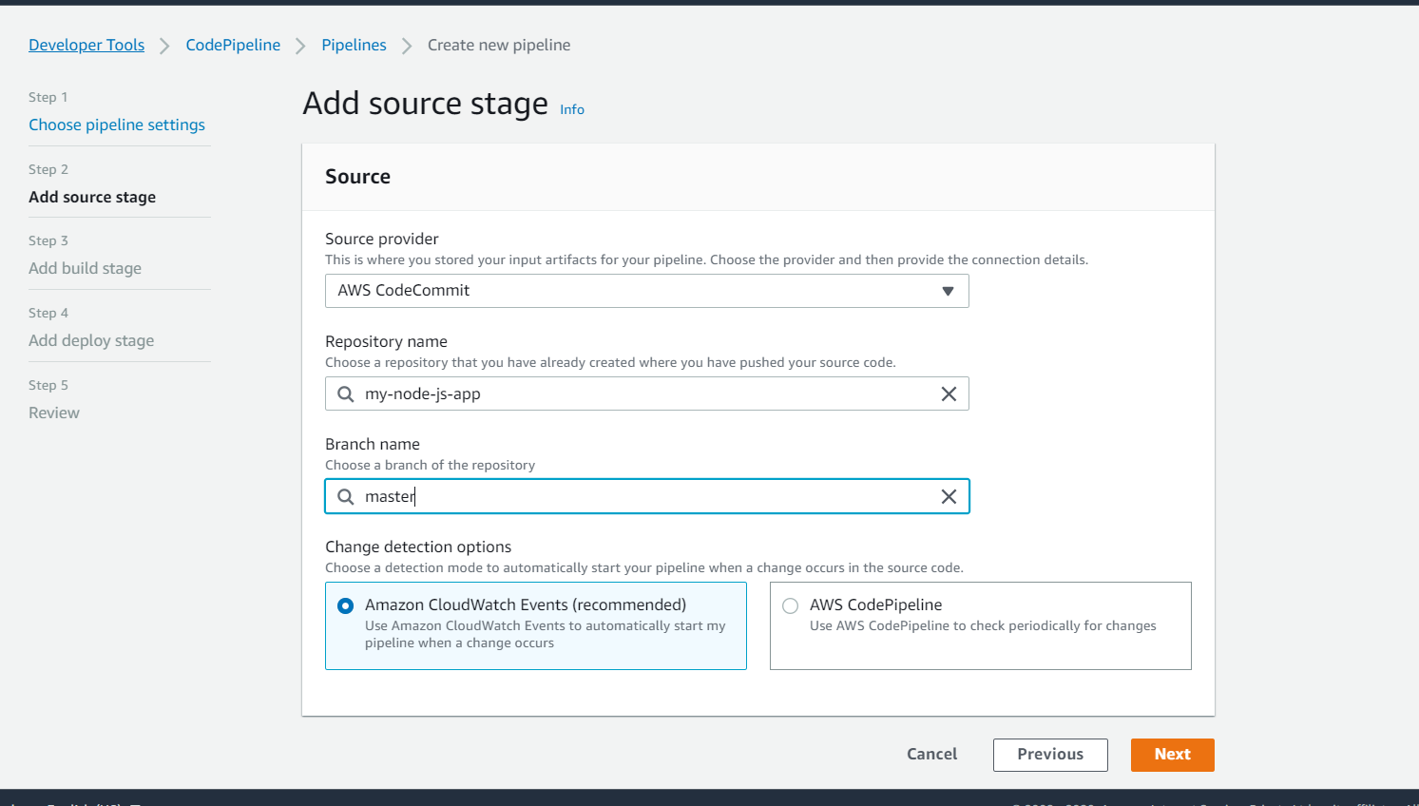

**Step 3) skip build stage**

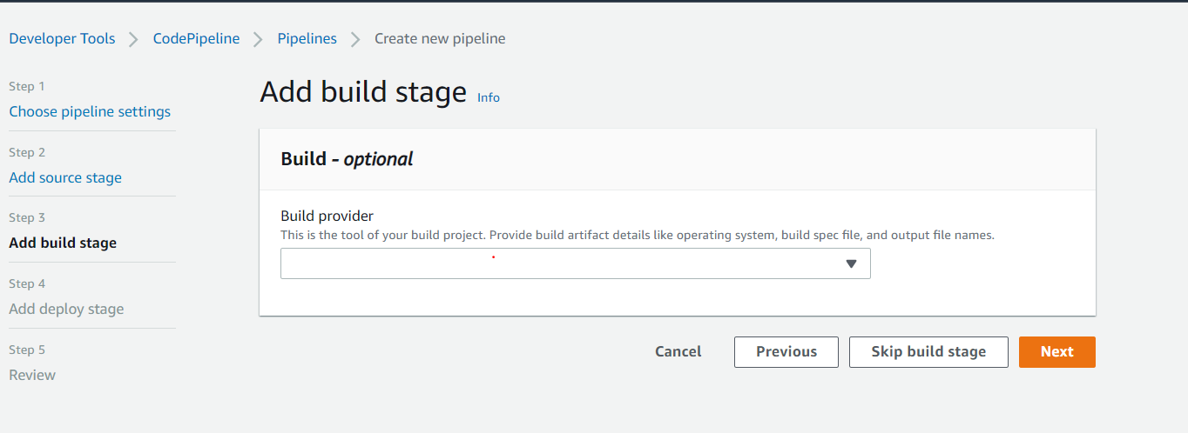

**Step 4)**

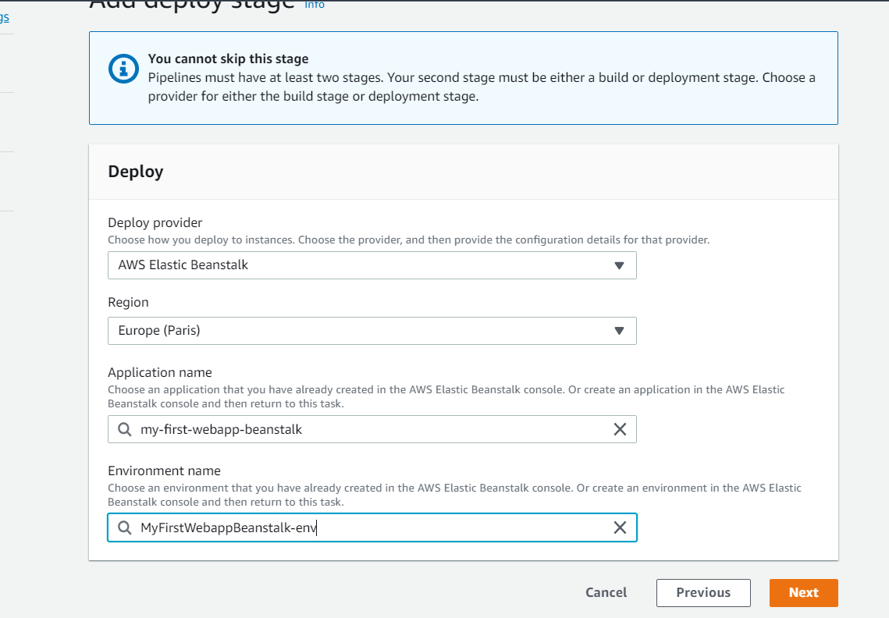

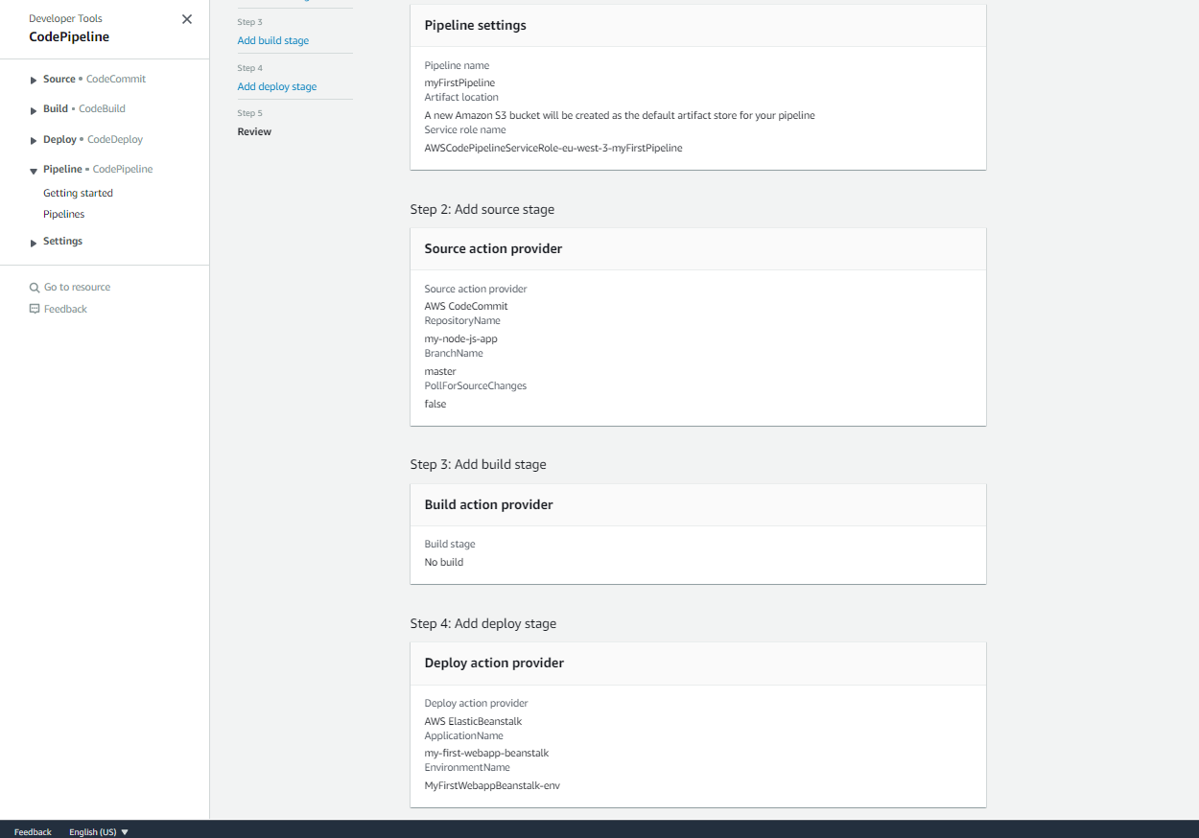

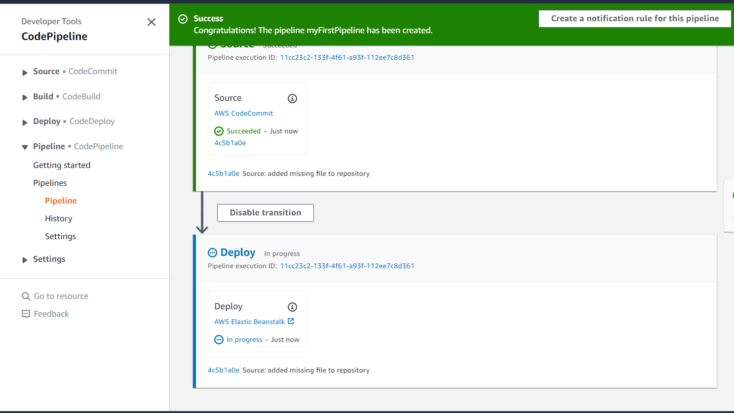

**Add more fun**

**Deploy to prod**

**Click edit**

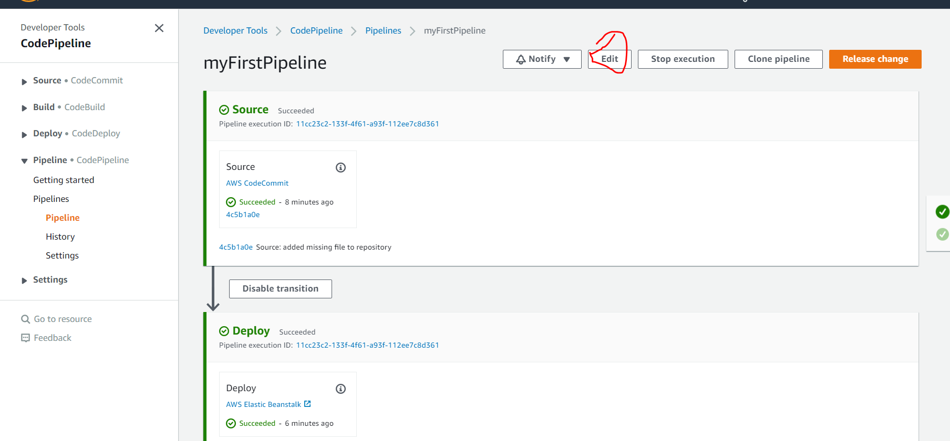

**Click add stage**

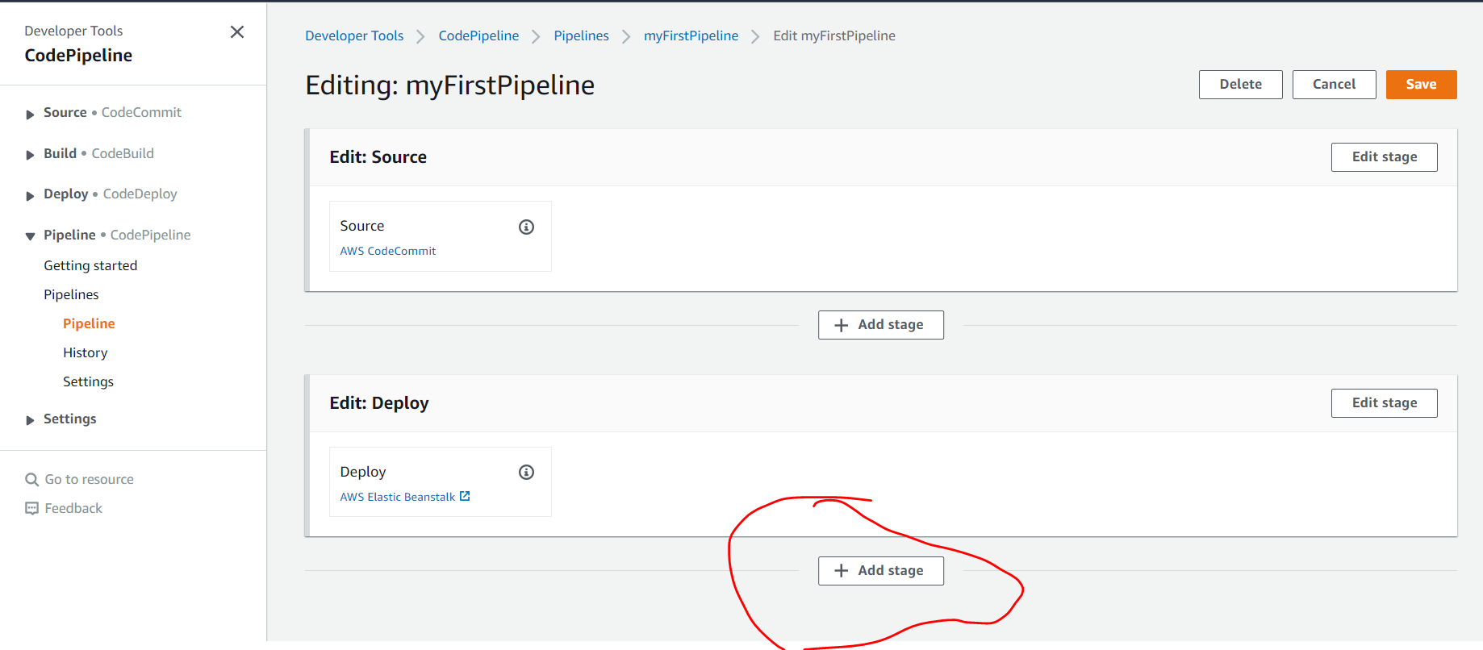

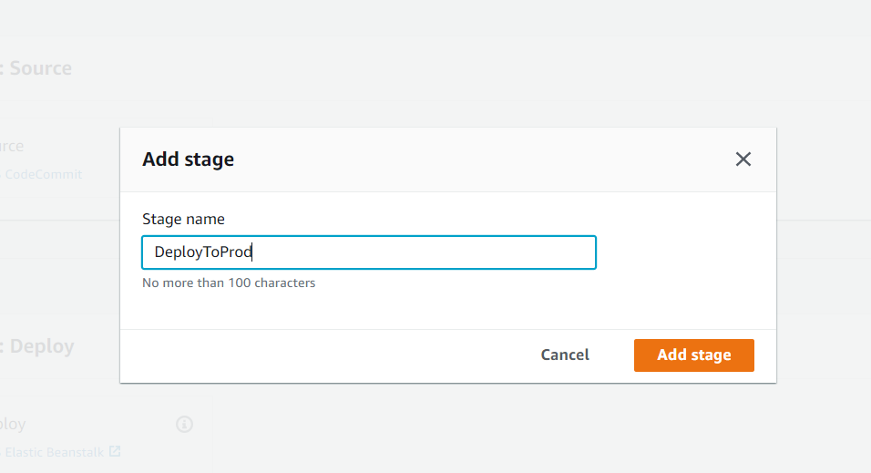

**Click add action group**

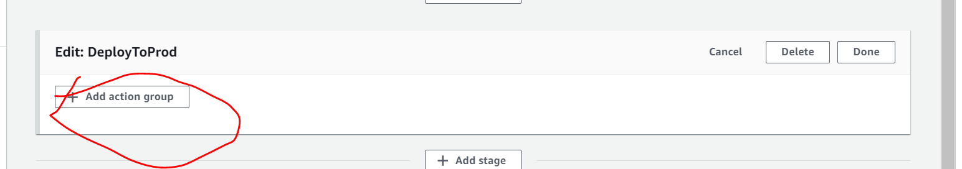

**Note we want to send code in prod when manual approval is there**

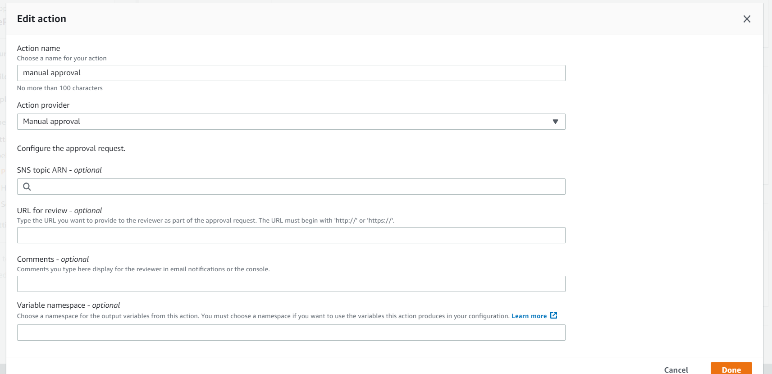

**Note we can add another action group**

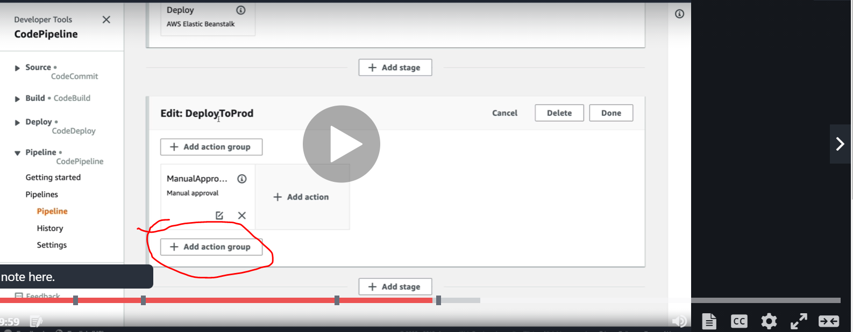

**Note:**

**Stages can have multiple action groups**

**Note:**

**We can add action group sequential and parallel**

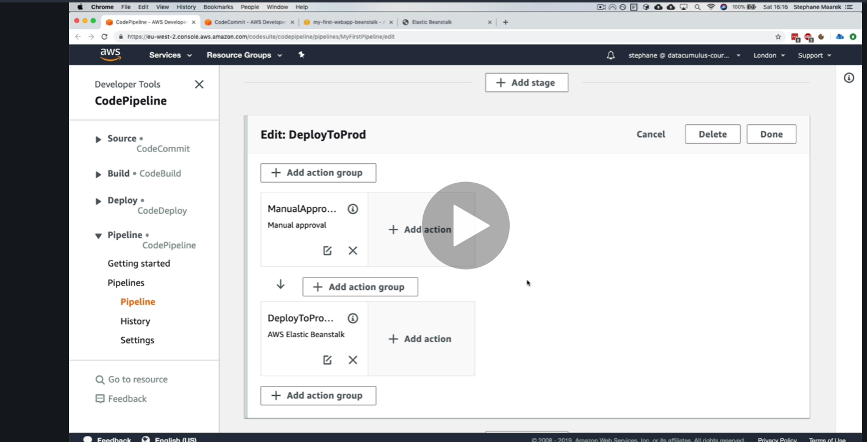

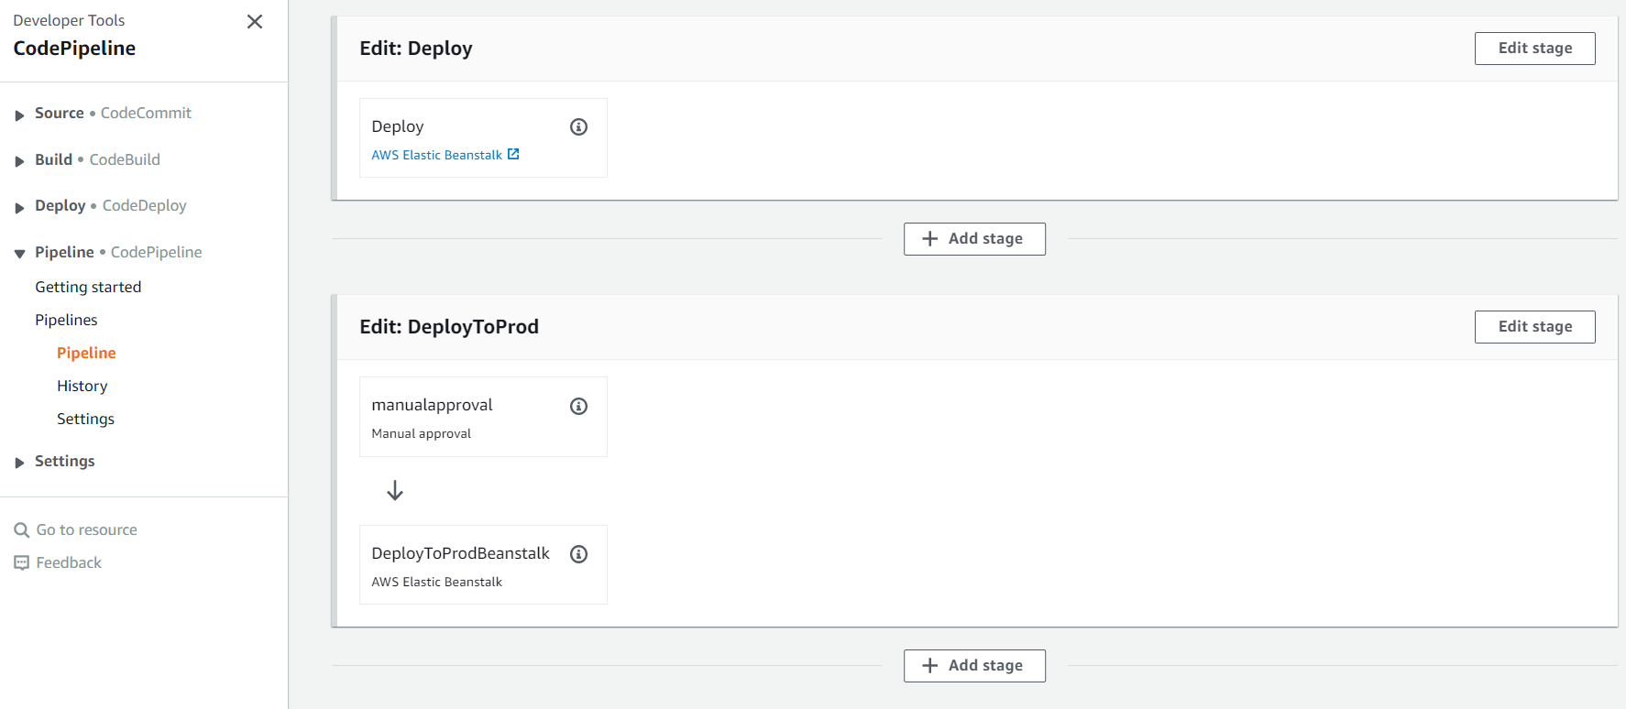

**NOTE:**

**Once we did change pipeline will start in index.html**

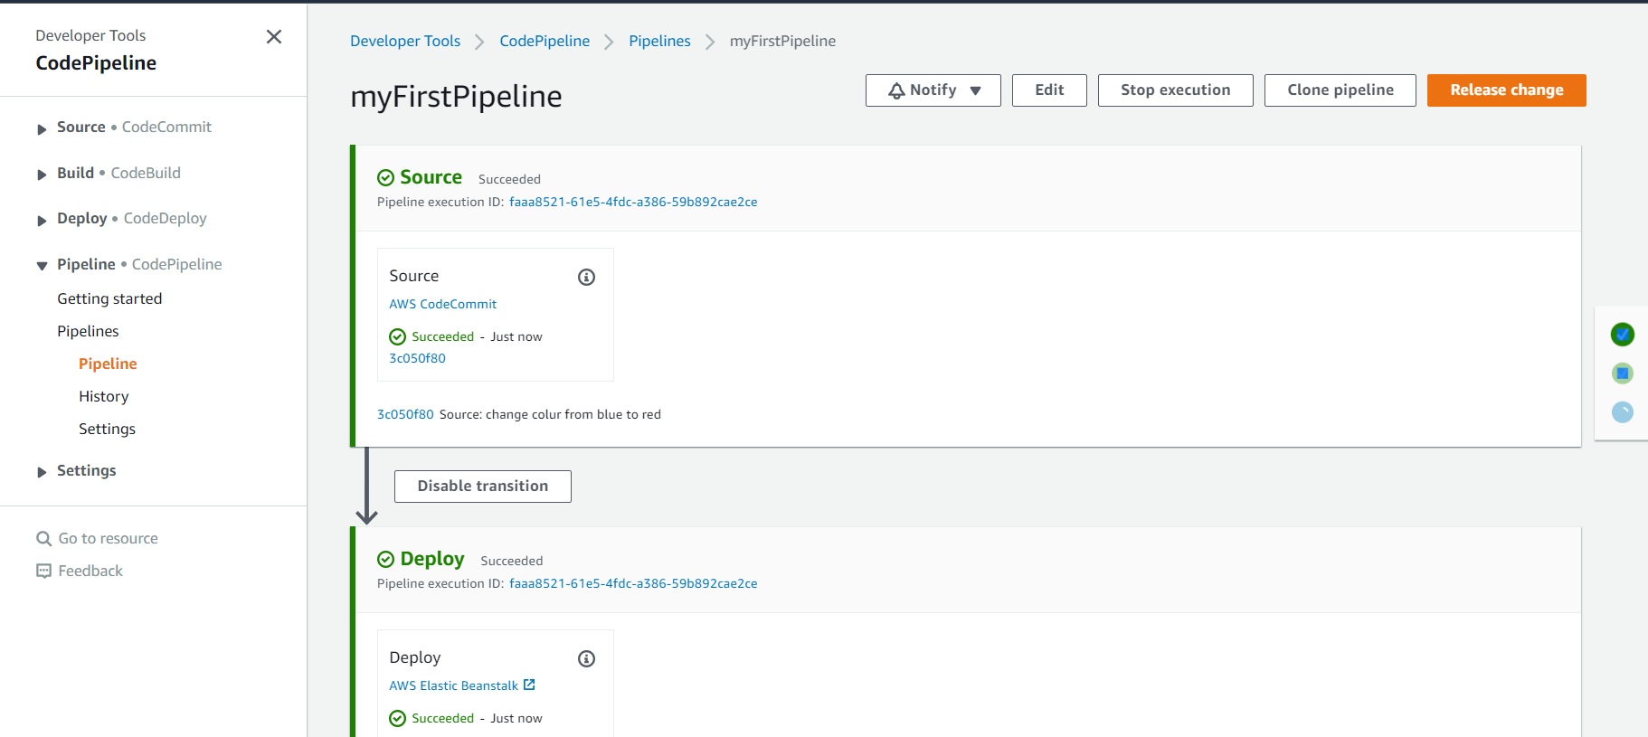

**For secind case we did manual approval so once it is approve it will start**

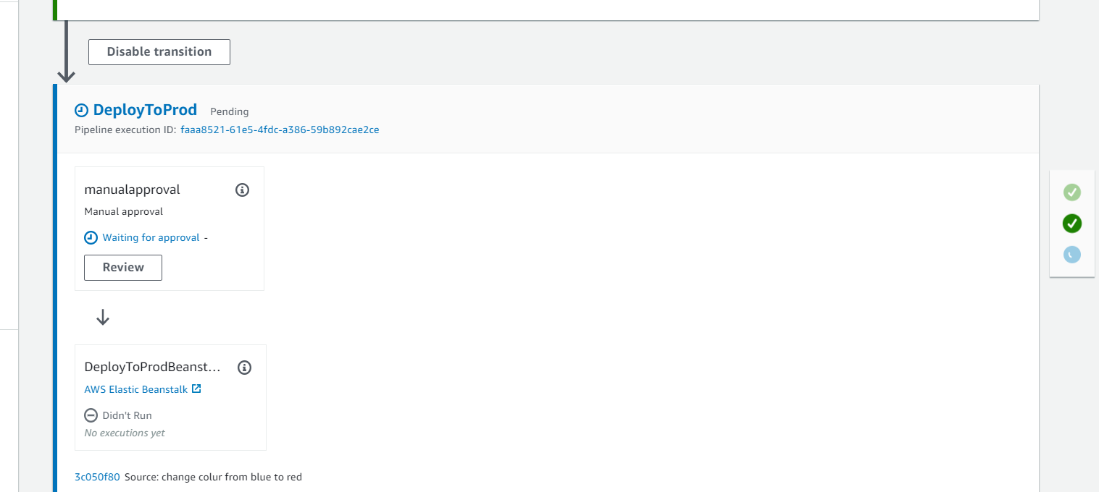

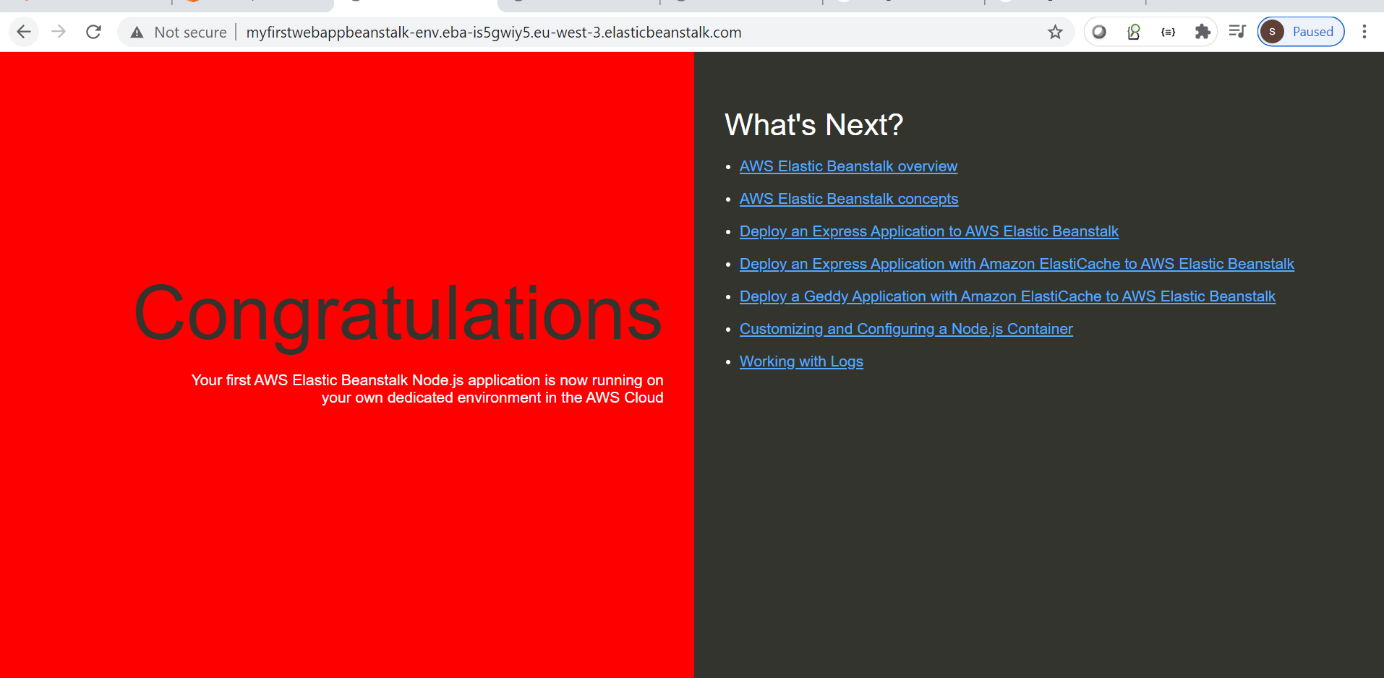

**Note :**

**We can also check history**

**Code build Overview**

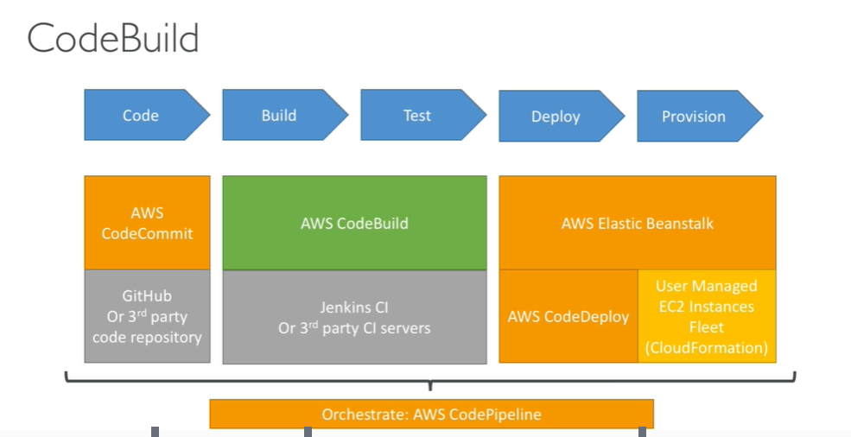

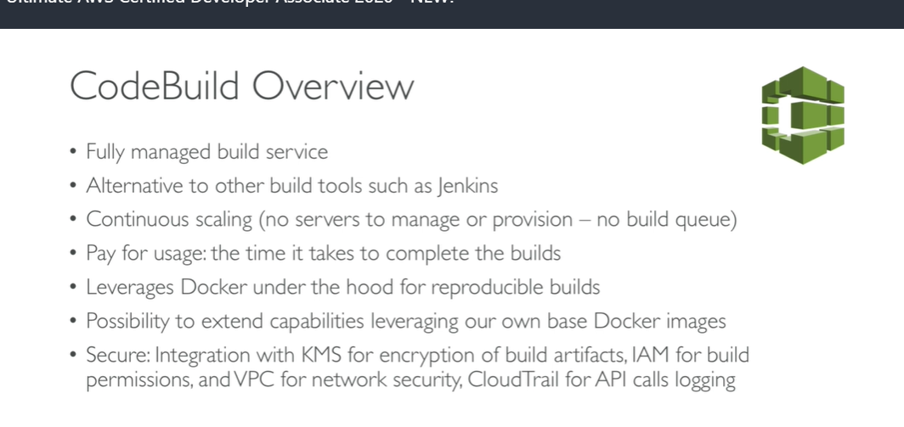

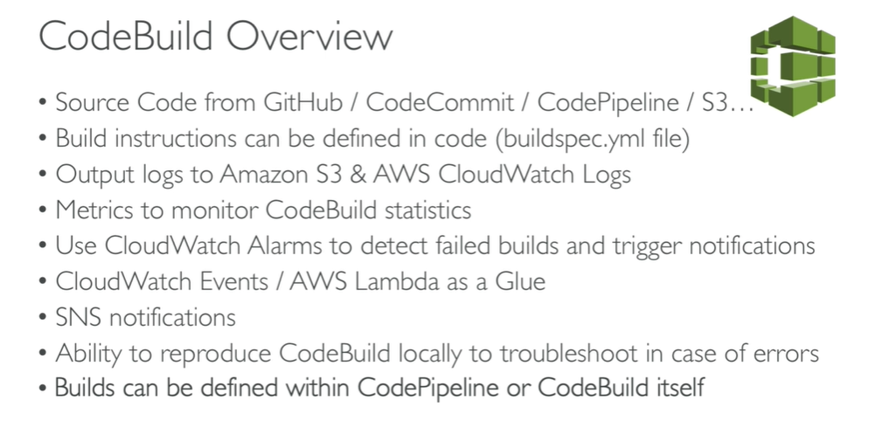

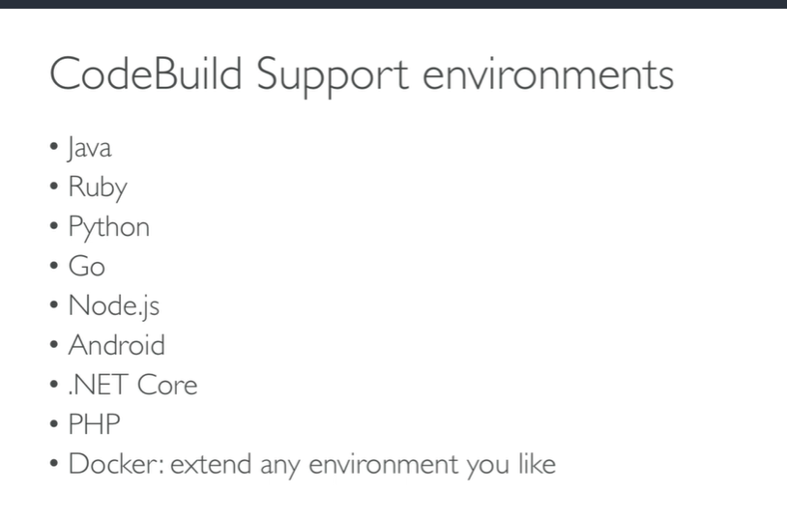

**output)**

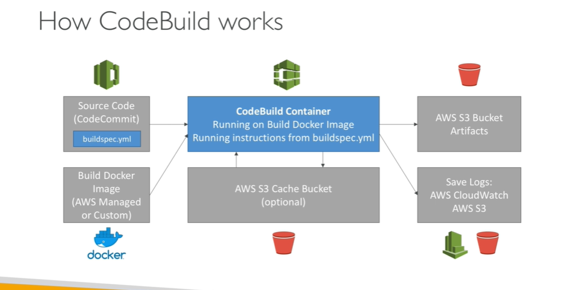

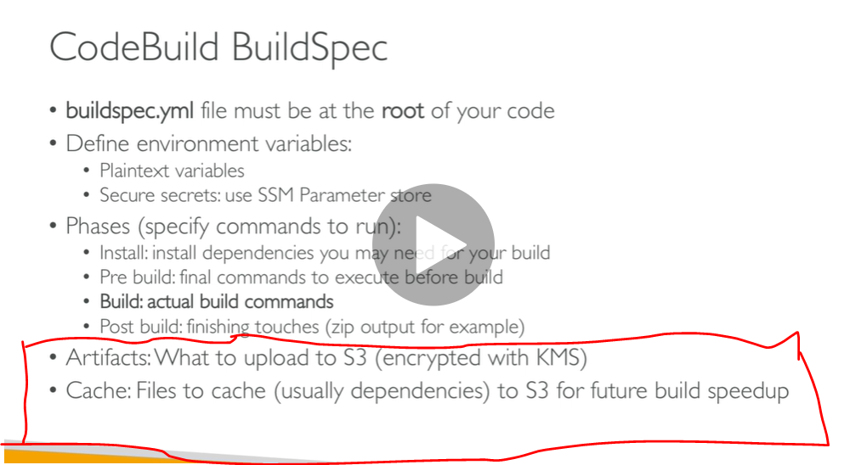

**Code build hands on part 1)**

**For deploy we are using elastic beanstalk**

**Code commit**

**Codebuild**

**Codedeploy**

**All prcess will be done cede pipeline**

**To test our code in code pipeline**

**Step 1)**

**Click codebuild**

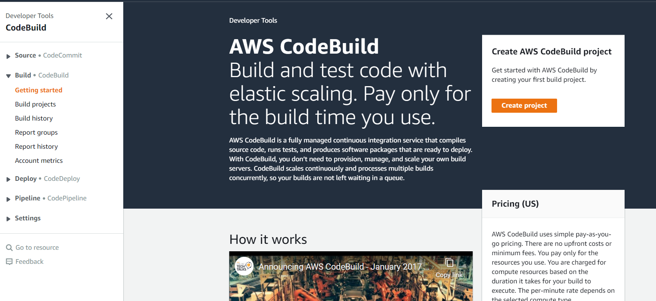

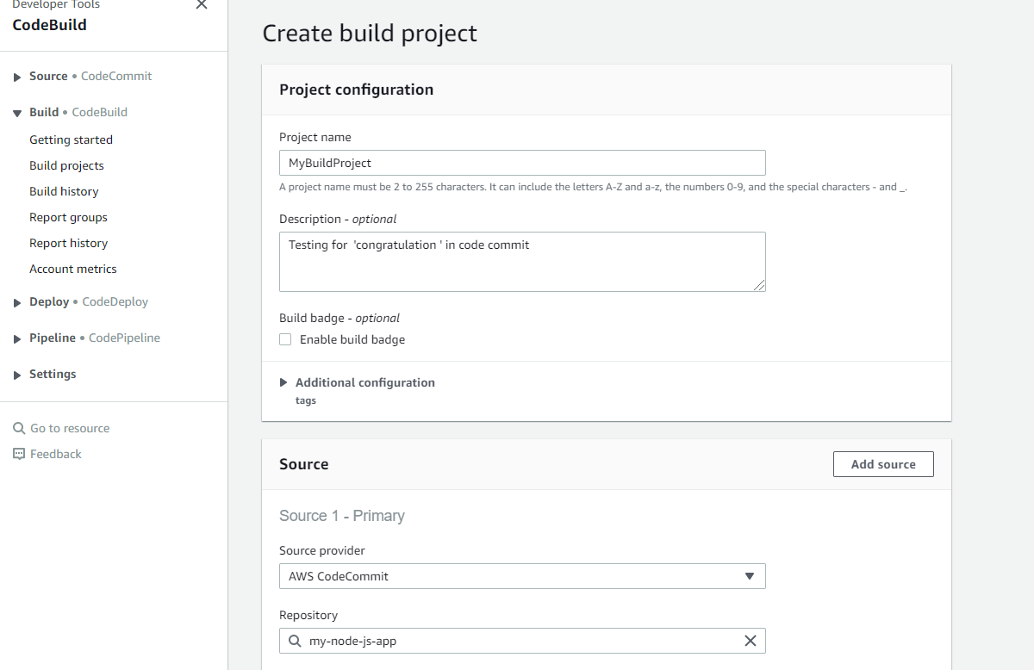

**Note : build run a docker image that will run test**

**We can use two type of image:**

**Manage : that will be do by aws**

**Custom**

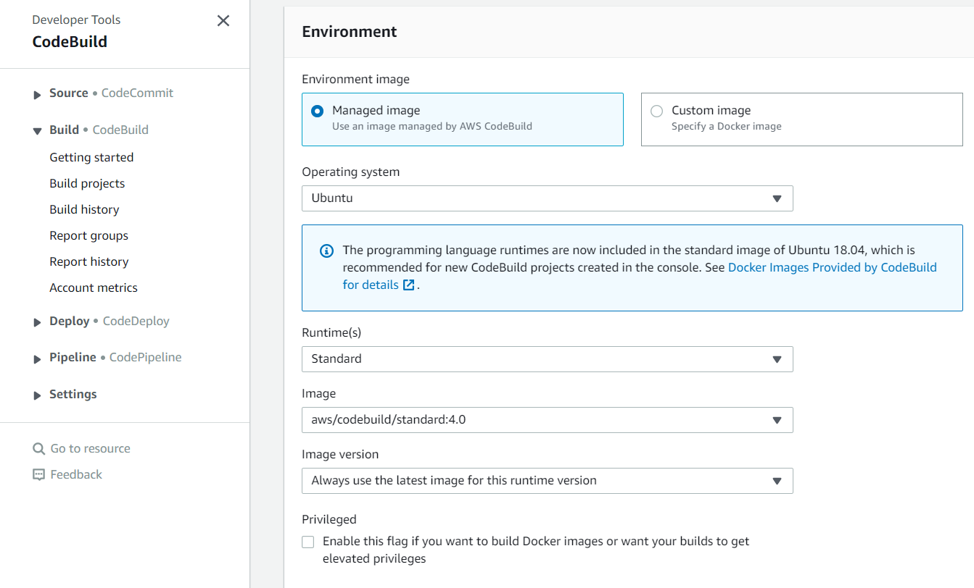

**Also we can set time out how long my build will run**

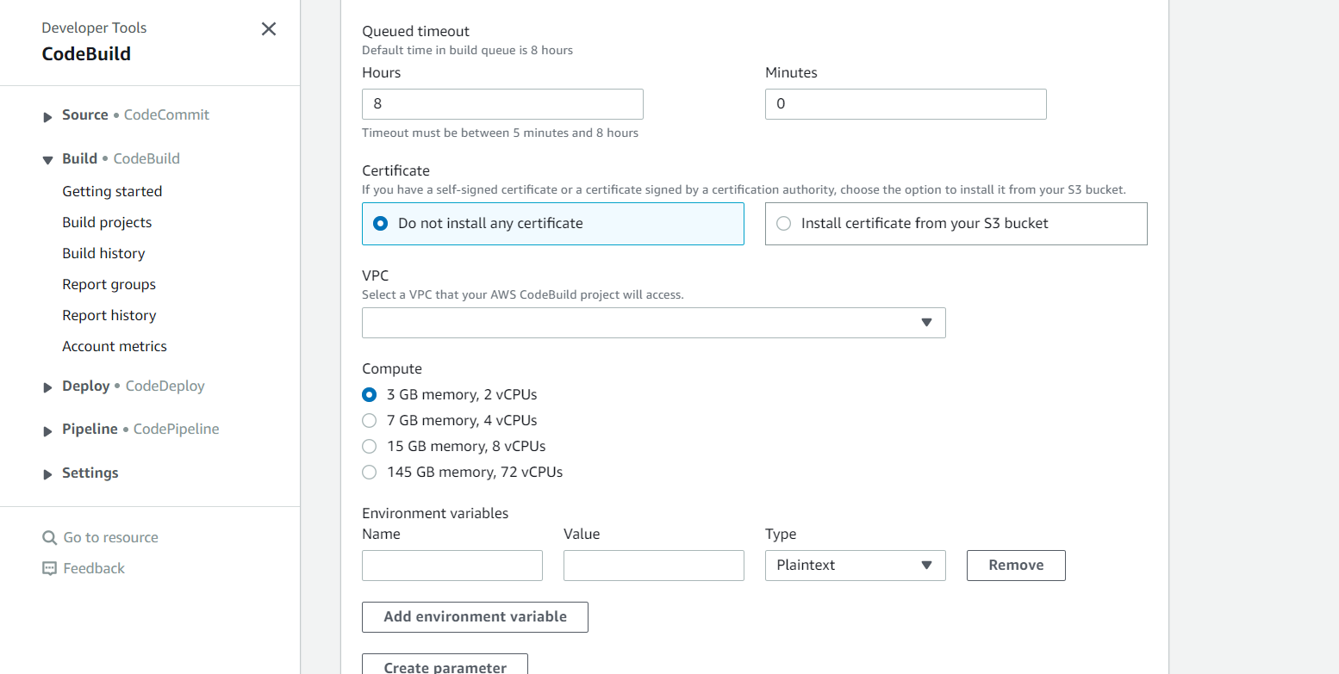

**NOTE : we can also add environment variable**

**Most important :**

**Build spec : it will tell how to build our project**

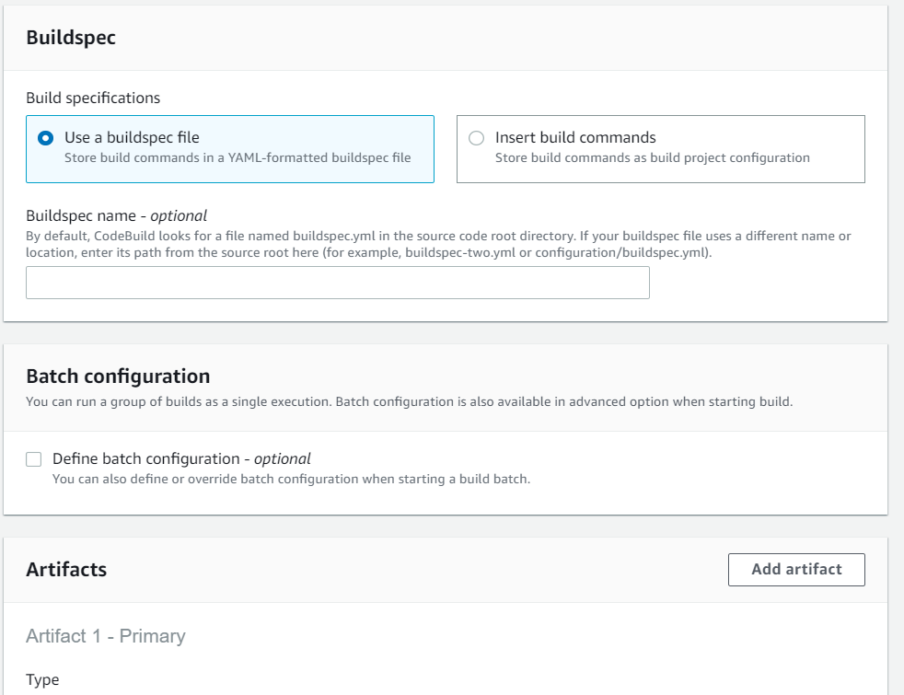

**Note we can also use artifact to improve performance**

**Now click on start build**

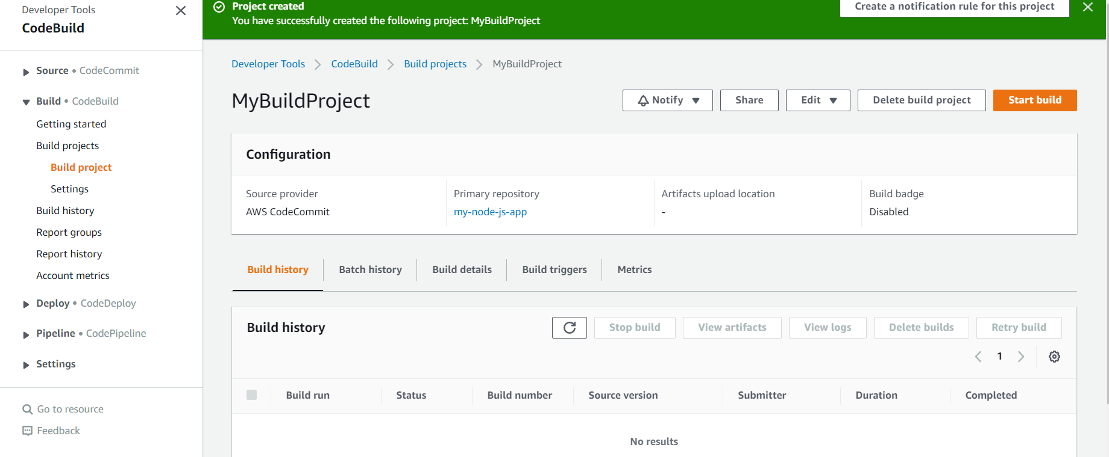

**Build failed :**

**Error comes from download source**

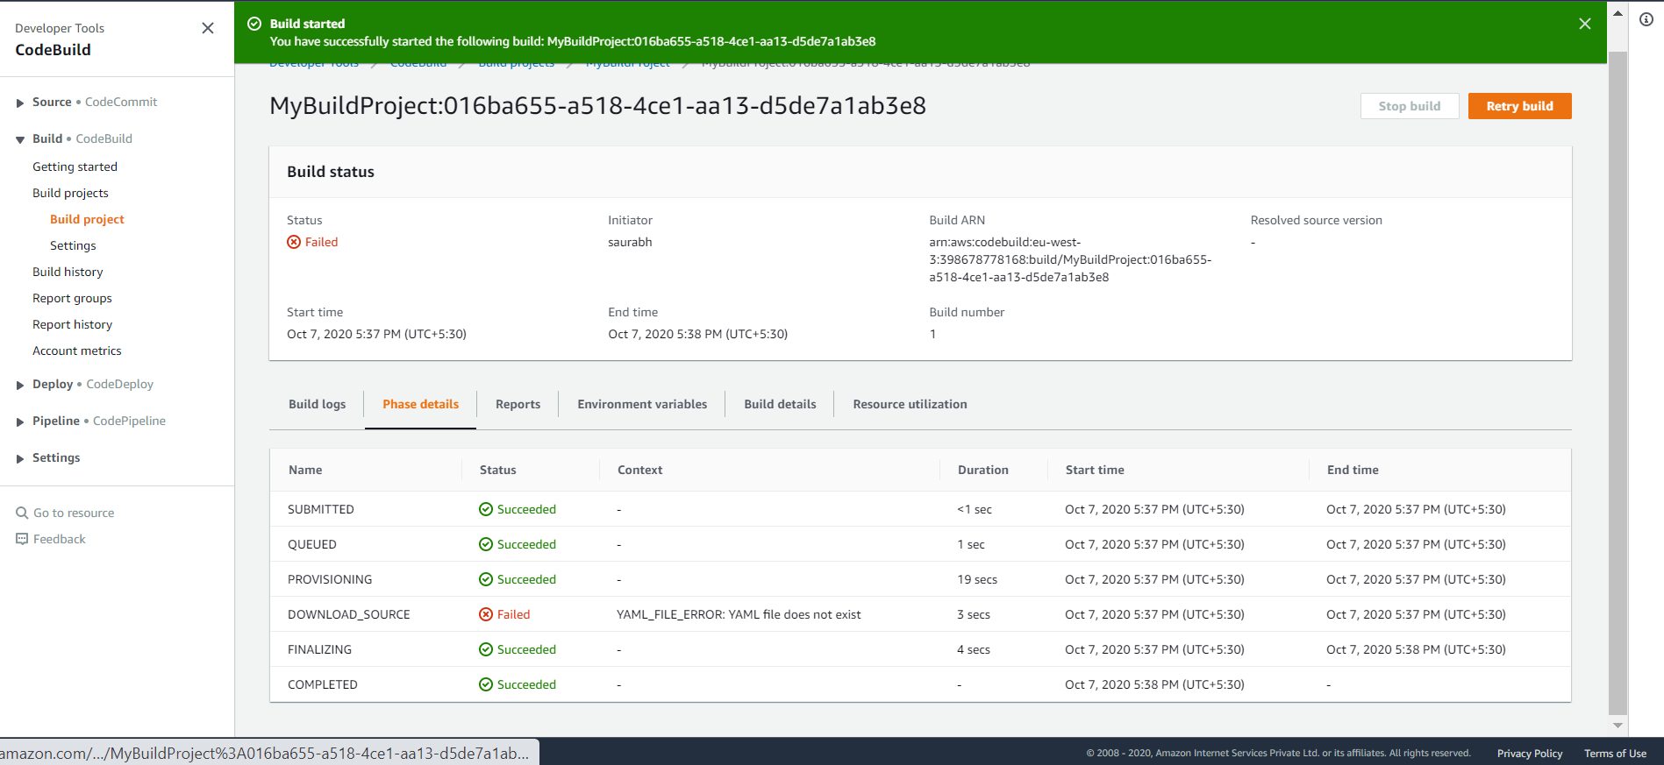

**Because this is looking for buildspec.yml in codecommit repository**

To resolve above problem add the missing yaml file

Code build hands on part 2

Create a file in codecommit

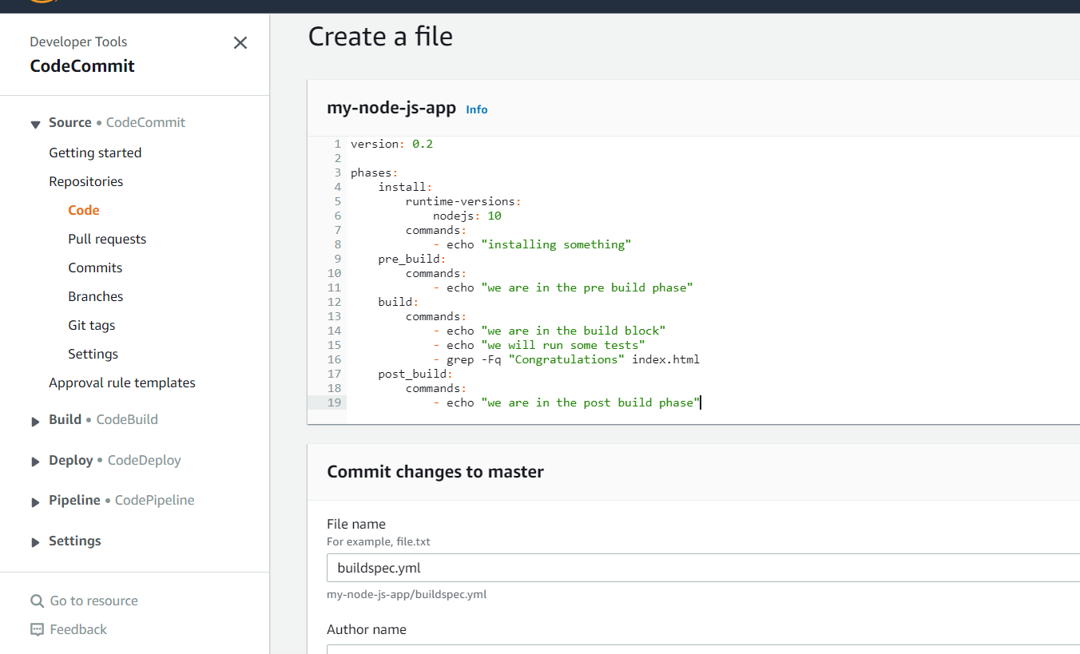

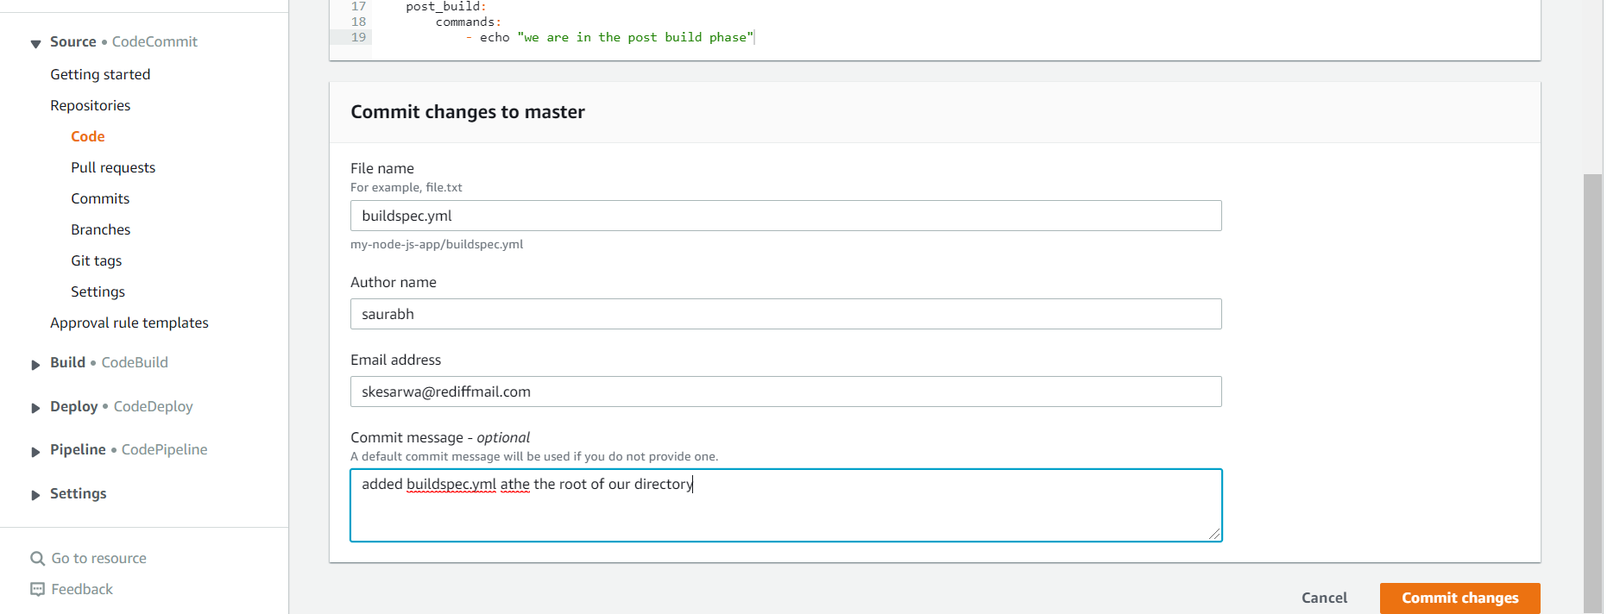

Now file is committed

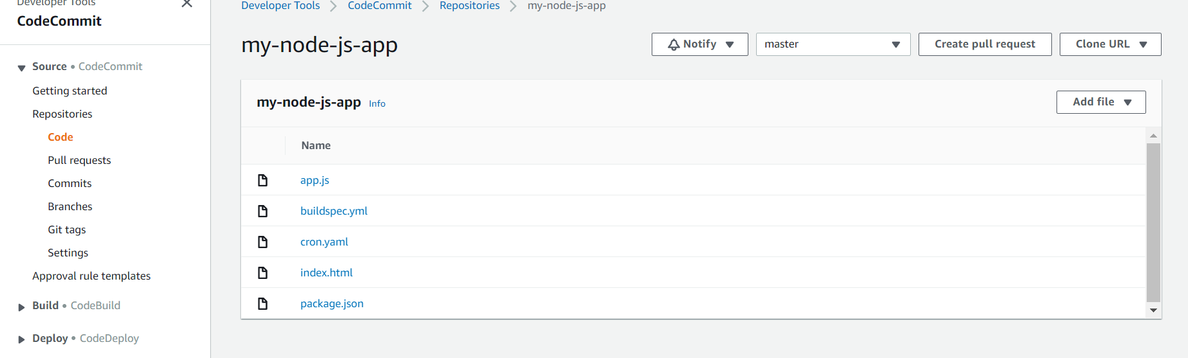

Start new build with same configuration:

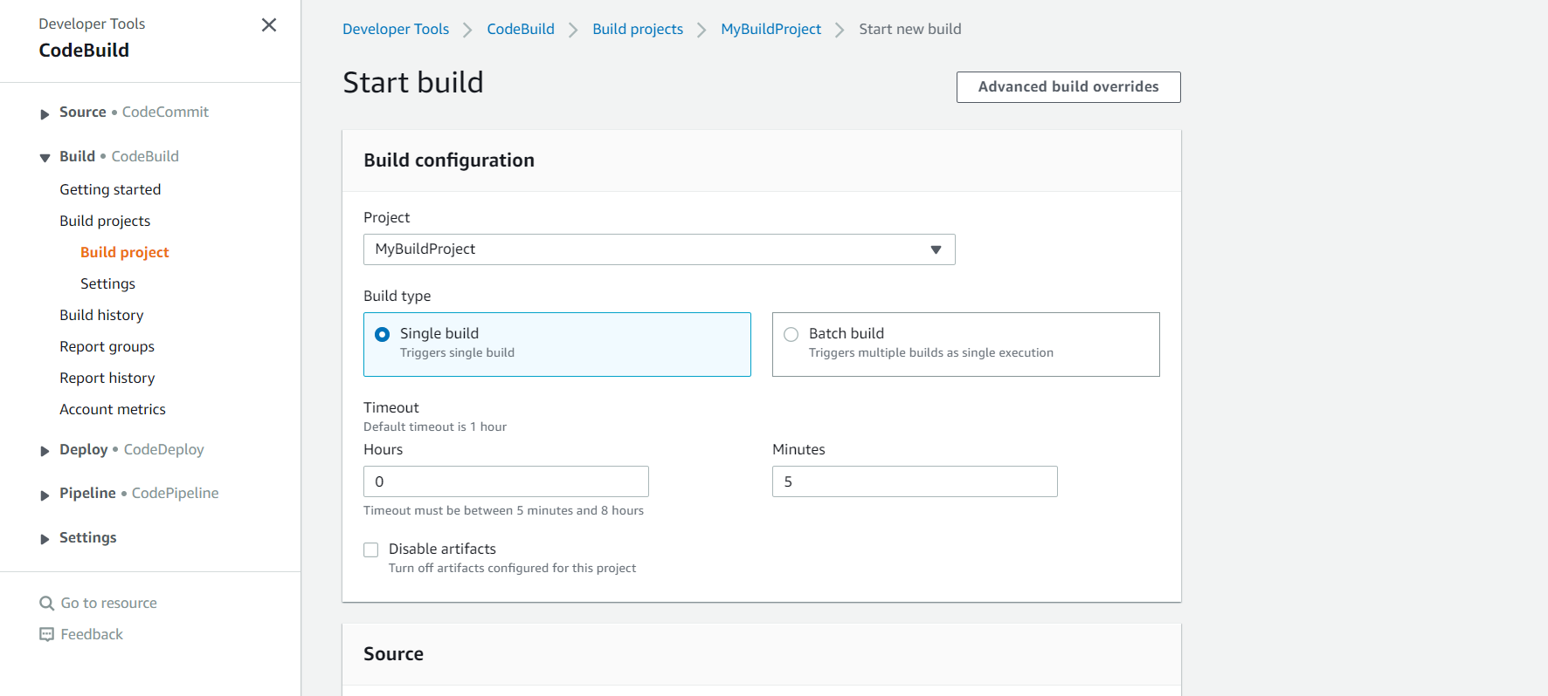

Wow this time build is succeeded

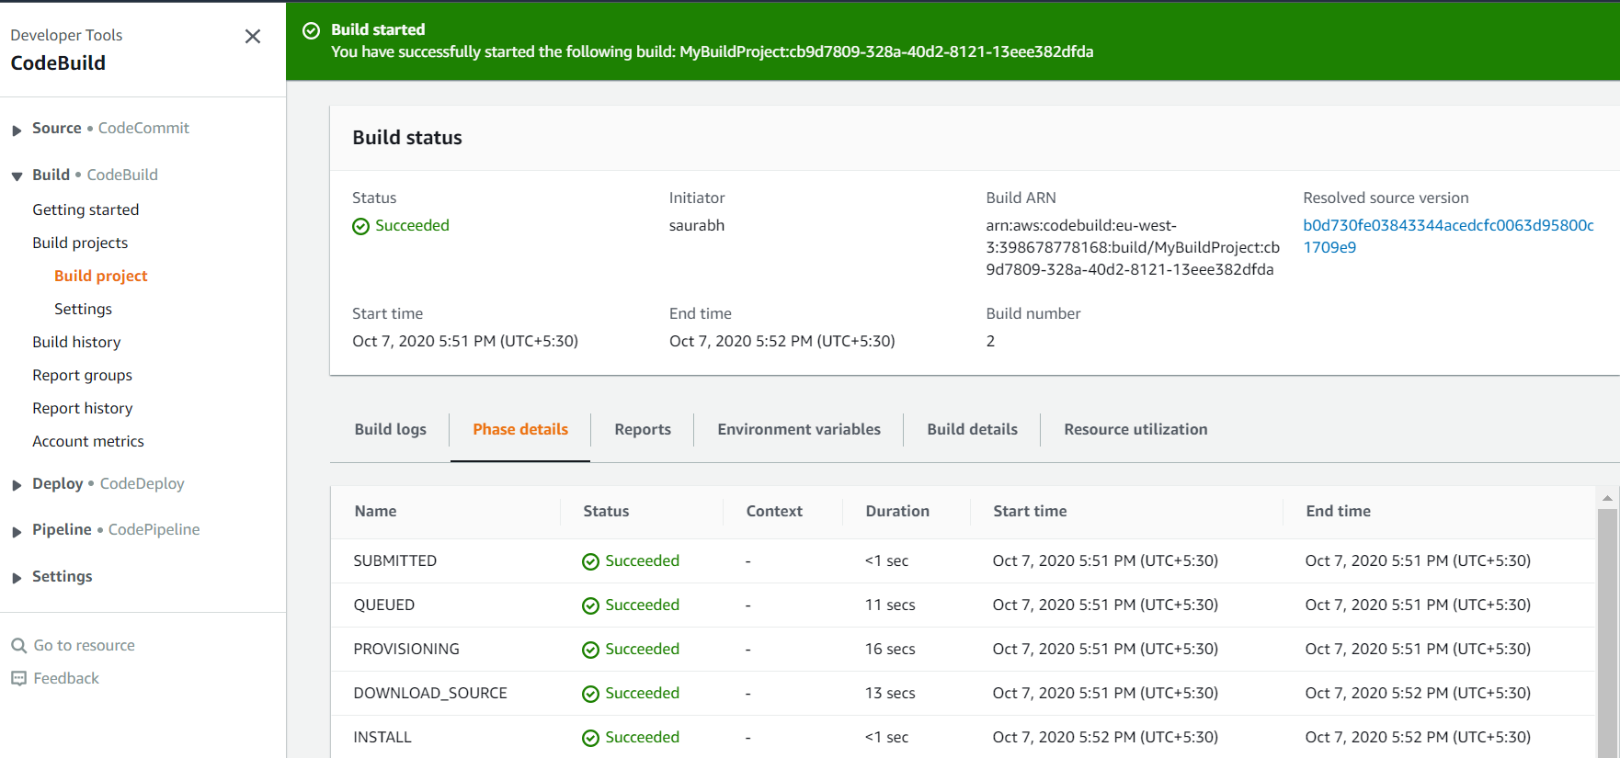

We can see each phase of build

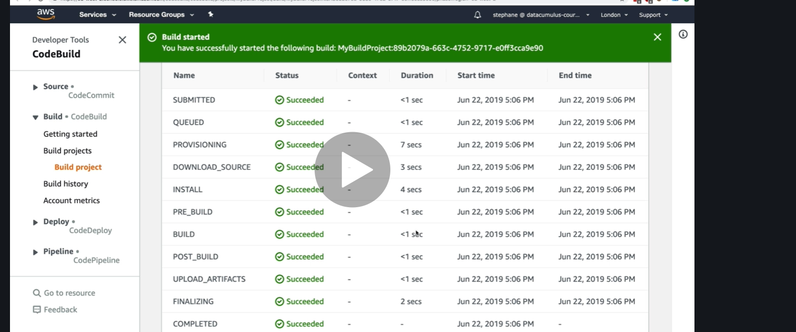

Imp :**To see log completely click view entire log and this will take into cloudwatch ui**

![Machine generated alternative text:
Developer Tools 
CodeBuild 
Source • CodeCommit 
V Build • CodeBuild 
Getting started 
Build projects 
Build project 
Settings 
Build history 
12:21: 
Report groups 
12:21: 
Report history 
12:21: 
12:21: 
Account metrics 
Deploy • CodeDeploy 
Pipeline • CodePipeline 
12:22: 
Settings 
12:22: 
12:22: 
12:22: 
Q Go to resource 
12:22: 
Feedback 
12:22: 
12:22: 
12:22. 
@ Build started 
You have successfully started the following build. 
• MyBui1dProject•cb9d7809-328a-40d2-8121-13eee382dfda 
x 
Tail logs 
Build logs 
Phase details 
Reports 
Environment variables 
Build details 
Resource utilization 
Showing the last 49 lines of the build log. 
1 
2 
3 
4 
5 
6 
7 
8 
9 
11 
12 
13 
14 
15 
16 
17 
18 
19 
21 
22 
23 
24 
L Container) 
L Container) 
L Container) 
L Container) 
L Container) 
2929/19/97 
2929/19/97 
2929/19/97 
2929/19/97 
2929/19/97 
12 
12 
: 21: 
12:21:51 
12:21:51 
45 
51 
51 
51 
51 
Show previous logs 
Waiting for agent ping 
47 Waiting for DWNLOAD SOURCE 
Phase is DWNLOAD SOURCE 
CODEBUILD SRC DIR—/codebui1d/output/src389791Ø13/src/git-codecommit.eu-west-3.amazonaws.com/vl/repos/my-node-js-app 
YAML location is /codebui1d/output/src389791ø13/src/git-codecomnit.eu-west-3.amazonaws.com/vl/repos/my-node-js- 
Processing environment variables 
Selecting ' nodejs' runtime version '1B' based on manual selections... 
Running conunand echo "Installing Node . js version la . 
Running conunand n $NODE le VERSION 
app/buildspec. ym1 
L Container) 2829/18/97 
L Container) 2929/18/97 
L Container) 2929/18/97 
Installing Node . js version 19 . 
LContainer) 292Ø/19/97 12:21:51 
installed : v1ø.21.ø (with npm 6.14.4) 
L Container) 
L Container) 
L Container) 
L Container) 
L Container) 
L Container) 
L Container) 
L Container) 
L Container) 
L Container) 
L Container) 
2929/19/97 
2929/19/97 
2929/19/97 
2929/19/97 
2929/19/97 
2929/19/97 
2929/19/97 
2929/19/97 
2929/19/97 
2829/1Ø/Ø7 
2929/19/97 
92 
92 
92 
92 
92 
92 
92 
• 92 
Moving to directory /codebui1d/output/src389791e13/src/git-codecom1it.eu-west-3.amazonaws.com/vl/repos/my-node-js-app 
Registering with agent 
Phases found in YML: 4 
INSTALL: 1 
PRE BUILD: 1 commands 
BUILD: 3 conunands 
POST BUILD: 1 comands 
Phase complete: DWNLOAD SOURCE State: SUCCEEDED 
Phase context status code: Message: 
Entering phase INSTALL 
Running conunand echo " installing something ](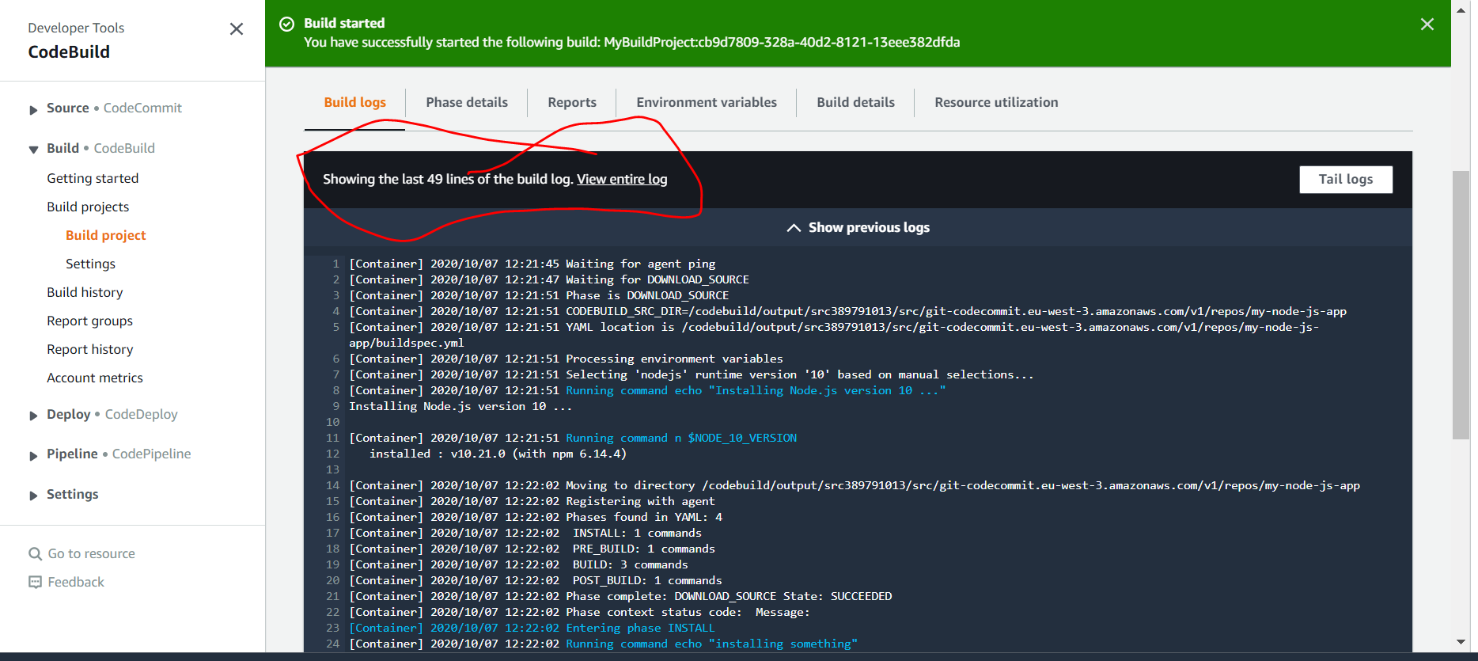)

![Machine generated alternative text:
aws 
Services v 
12:21. 
12:21. 
12:21. 
12:21. 
12:21. 
12:22. 
12:22. 
12:22. 
12:22. 
12:22. 
12:22. 
12:22. 
12:22. 
12:22. 
12:22. 
12:22. 
12:22. 
12:22. 
C eu-west-3.console.aws.amazon.com/cloudwatch/home?regionzeu-west-3#logsV2:log-groups/log-group/$252Faws$252Fco... 
saurabh @ awsdeveloperlearn v 
Paused 
Paris V Support V 
LContainer) 
LContainer) 
LContainer) 
LContainer) 
LContainer) 
2828/1e/B7 
2828/1e/B7 
2828/1e/B7 
2828/1e/B7 
2828/1e/B7 
2828-1e-e7T17 : 52 : es. sg€+as : 
2828-1e-e7T17 : 52 : es. sg€+as : 
2828-1e-e7T17 : 52 : es. sg€+as : 
2828-1e-e7T17 : 52 : es. sg€+as : 
2828-1e-e7T17 : 52 : es. sg€+as : 
2828-1e-e7T17 : 52 : es. sg€+as : 
2828-1e-e7T17 : 52 : es. sg€+as : 
2828-1e-e7T17 : 52 : es. sg€+as : 
2828-1e-e7T17 : 52 : es. sg€+as : 
2828-1e-e7T17 : 52 : es. sg€+as : 
2828-1e-e7T17 : 52 : es. sg€+as : 
2828-1e-e7T17 : 52 : es. sg€+as : 
2828-1e-e7T17 : 52 : es. sg€+as : 
2828-1e-e7T17 : 52 : es. sg€+as : 
2828-1e-e7T17 : 52 : es. sg€+as : 
2828-1e-e7T17 : 52 : es. sg€+as : 
2828-1e-e7T17 : 52 : es. sg€+as : 
2828-1e-e7T17 : 52 : es. sg€+as : 
2828-1e-e7T17 : 52 : es. sg€+as : 
2828-1e-e7T17 : 52 : es. sg€+as : 
2828-1e-e7T17 : 52 : es. sg€+as : 
2828-1e-e7T17 : 52 : es. sg€+as : 
2828-1e-e7T17 : 52 : es. sg€+as : 
2828-1e-e7T17 : 52 : es. sg€+as : 
2828-1e-e7T17 : 52 : es. sg€+as : 
2828-1e-e7T17 : 52 : es. sg€+as : 
2828-1e-e7T17 : 52 : es. sg€+as : 
2e2e-1e-a7T17: . sg€+as : 
CloudWatch 
Dashboards 
Alarms 
ALARM 
OK 
Billing 
Logs 
I Log groups 
Insights 
Metrics 
Events 
Rules 
Event Buses 
ServiceLens 
Service Map 
Traces 
Container Insights 
Resources 
Performance Monitoring 
Canaries 
Contributor Insights 
Settings 
Favorites 
CODEBIJILD SRC DIR—/codebui1d/output/src3897g1e13/src/git-codecommit.eu-west-3.amazonaws.com/vl/repos/my-node... 
YAML location is /codebui1d/output/src3897g1e13/src/git-codecommit.eu-west-3.amazonaws.com/vl/repos/my-node-... 
Processing environment variables 
Selecting ' nodejs' runtime version '18' based on manual selections. 
Running command echo "Installing Node. js version 1B . 
Running command n SNODE 1B VERSION 
Installing Node.js version 18 . 
LContainer) 
installed 
LContainer) 
LContainer) 
LContainer) 
LContainer) 
LContainer) 
LContainer) 
LContainer) 
LContainer) 
LContainer) 
LContainer) 
LContainer) 
2828/1e/B7 12:21 
vie. 21.e (with npm 6.14.4) 
2828/1e/B7 
2828/1e/B7 
2828/1e/B7 
2828/1e/B7 
2828/1e/B7 
2828/1e/B7 
2828/1e/B7 
2828/1e/B7 
2828/1e/B7 
2828/1e/B7 
2828/1e/B7 
12:22:e2 
12:22:e2 
Moving to directory /codebui1d/output/src38g7g1e13/src/git-codecommit.eu-west-3.amazonaws.com/vl/repos/my-no... 
Registering with agent 
Phases found in YAML: 4 
INSTALL: 1 commands 
PRE BUILD: 1 commands 
BUILD: 3 commands 
POST BUILD: 1 commands 
Phase complete: DOWNLOAD SOURCE state: 
Phase context status code: Message: 
Entering phase INSTALL 
SUCCEEDED 
Running command echo " installing something 
Phase complete: INSTALL state: SUCCEEDED 
Phase context status code: Message: 
Entering phase PRE BUILD 
Running command echo "we are in the pre build phase 
installing something 
Lcontainer) 2828/1e/B7 
Lcontainer) 2828/1e/B7 
Lcontainer) 2828/1e/B7 
Lcontainer) 2828/1e/B7 
we are in the pre build phase ](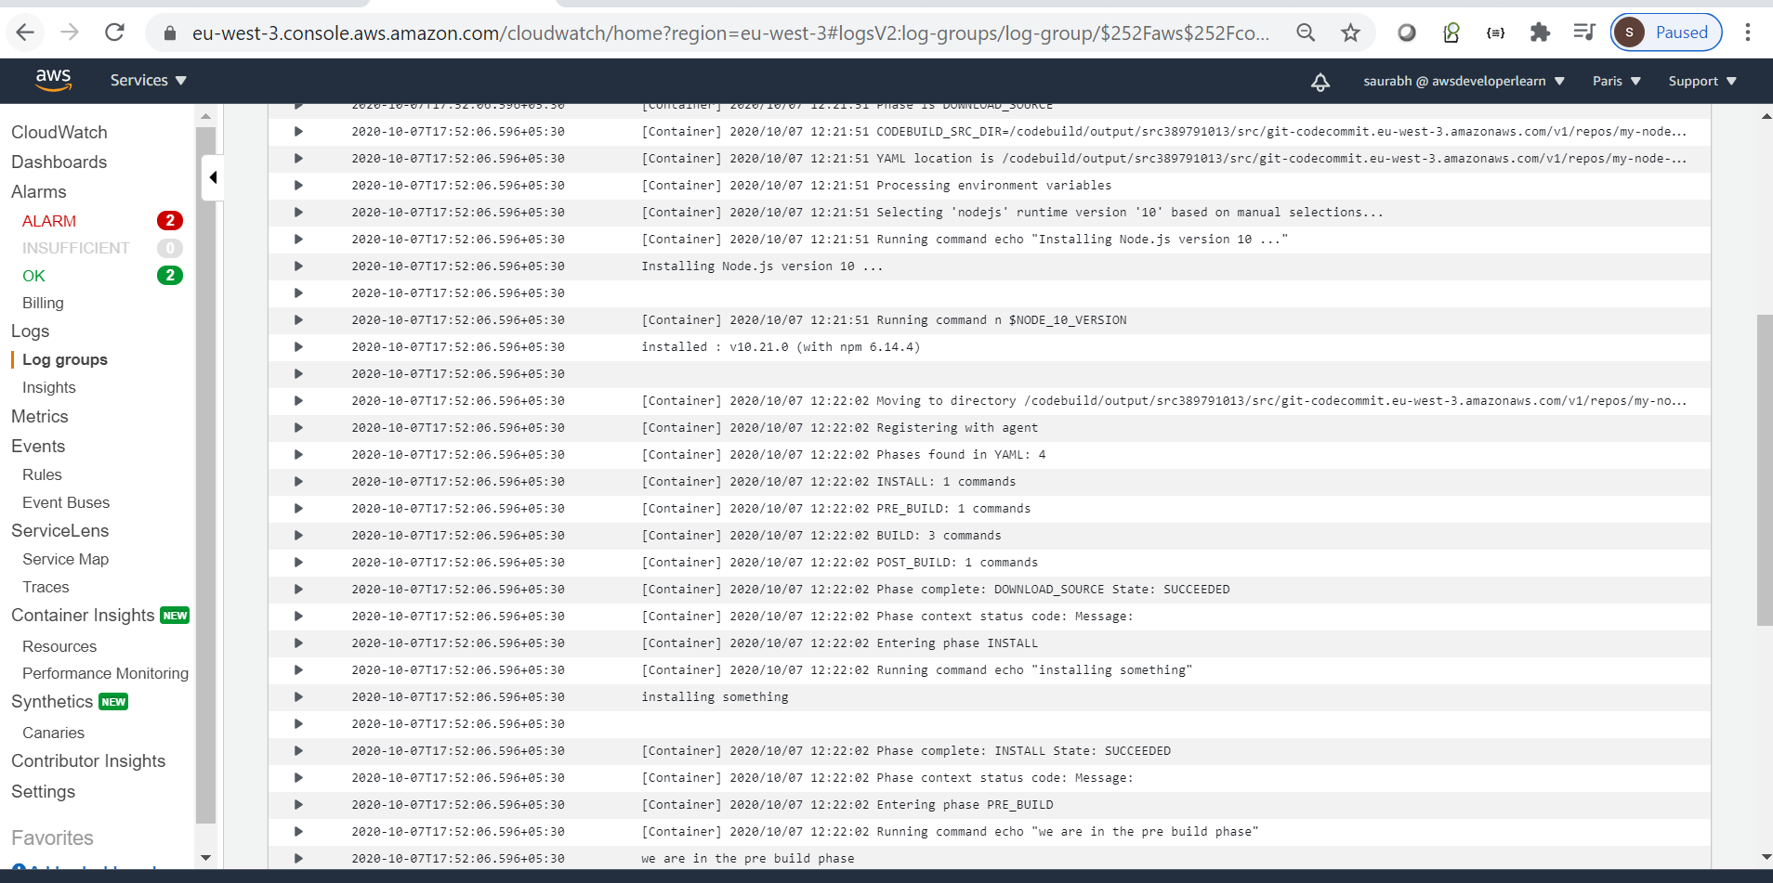)

**Requirement : how to integrate build project into code deploy**

Go to pipeline and between source and deploy add code build

**Click on edit pipeline**

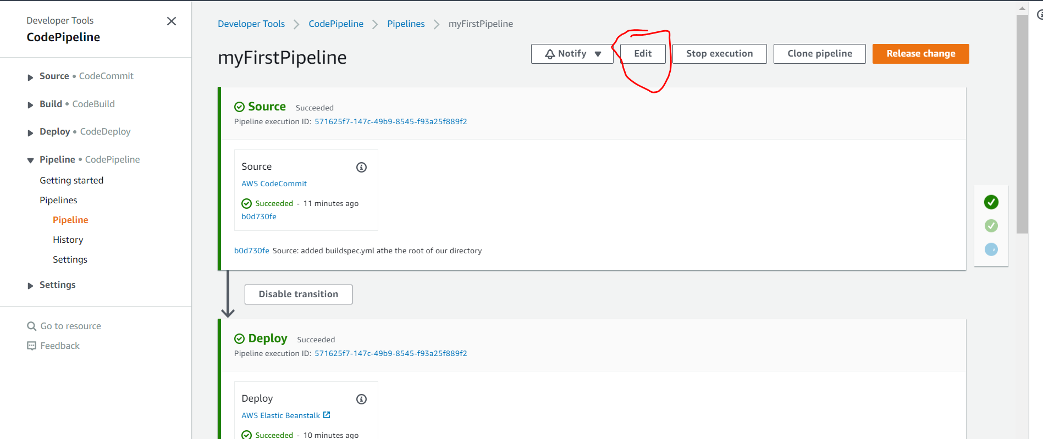

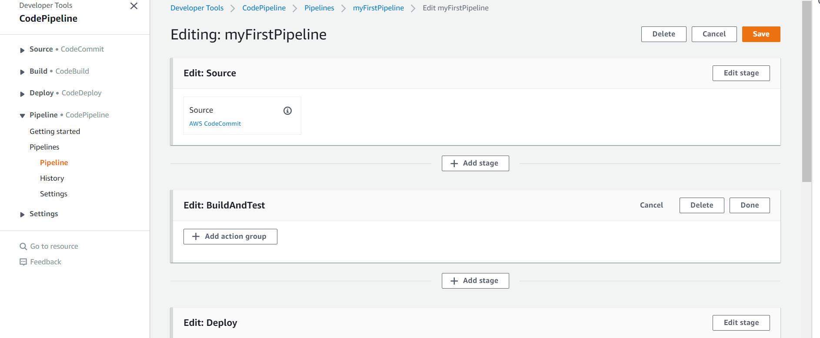

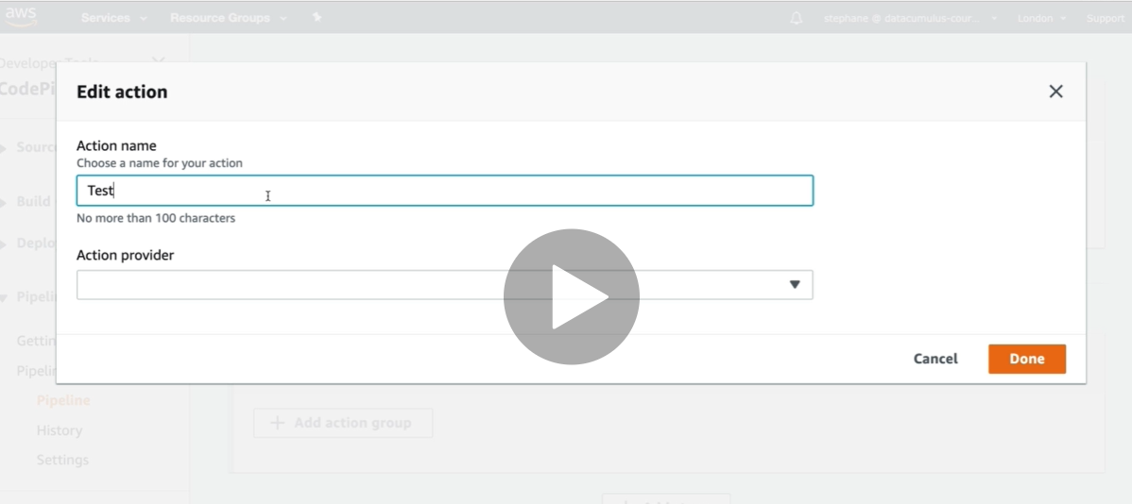

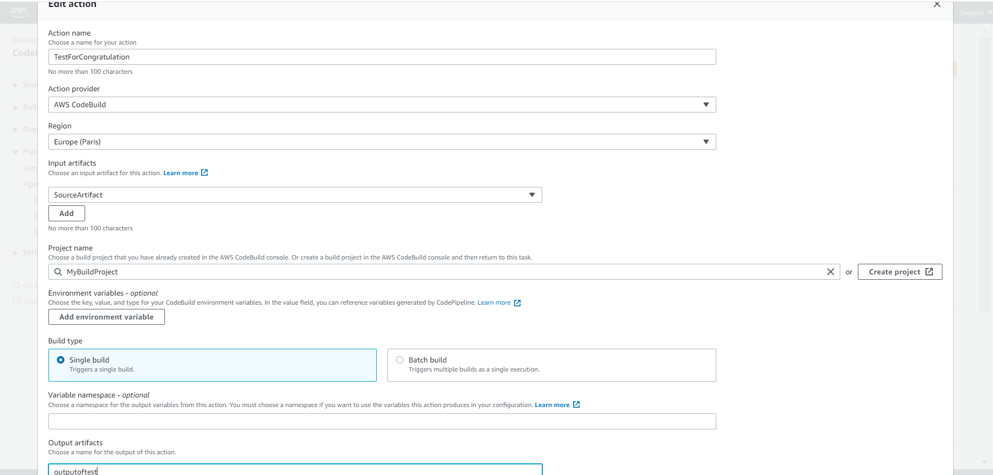

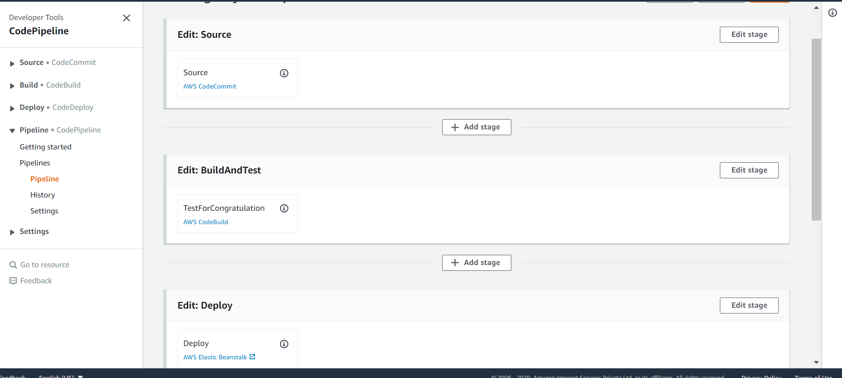

Now we need to test pipeline

**For this will change in index.html in codecommit**

And through pipeline all will happen automatically

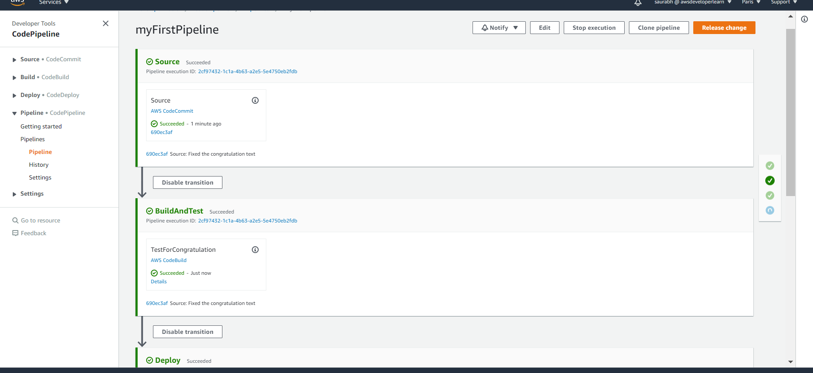

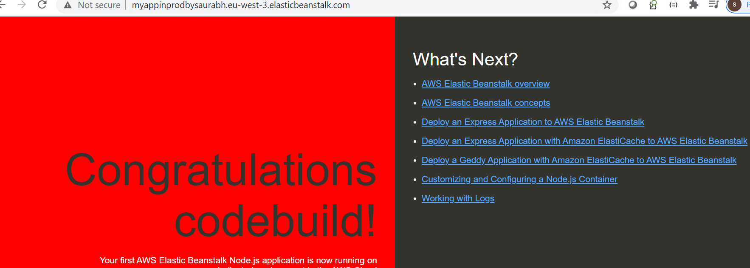

Code Build In VPC

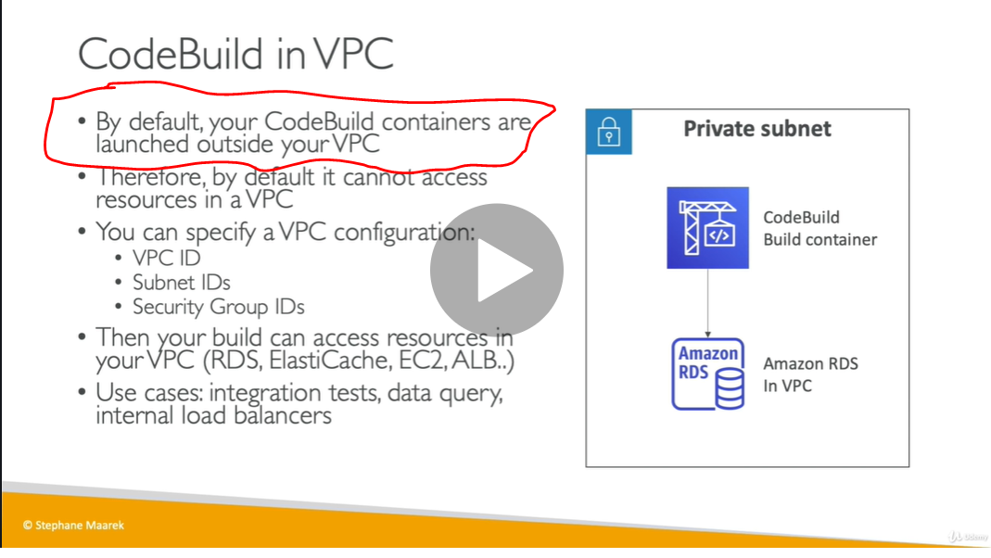

Note : want to configure vpc to codebuild since codebuild is outside of vpc

Codebuild/edit/environment

We can configure in codebuild vpc,subnet,security group

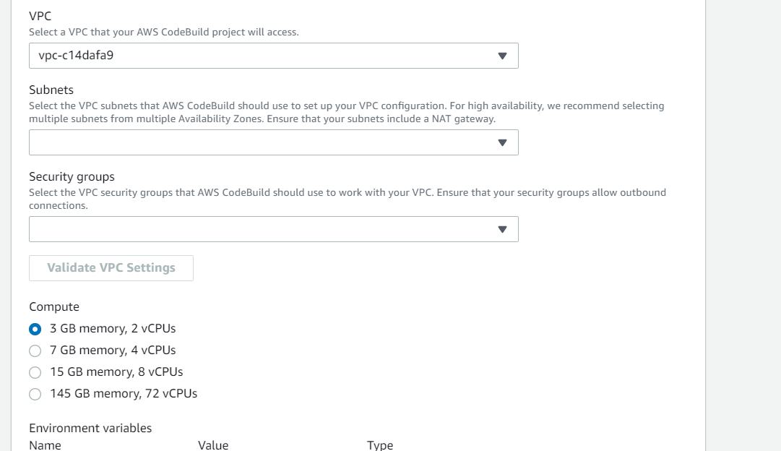

Code Deploy Overview

Requirement : want to deploy application in 100 of ec2 instance not by elastic beanstalk

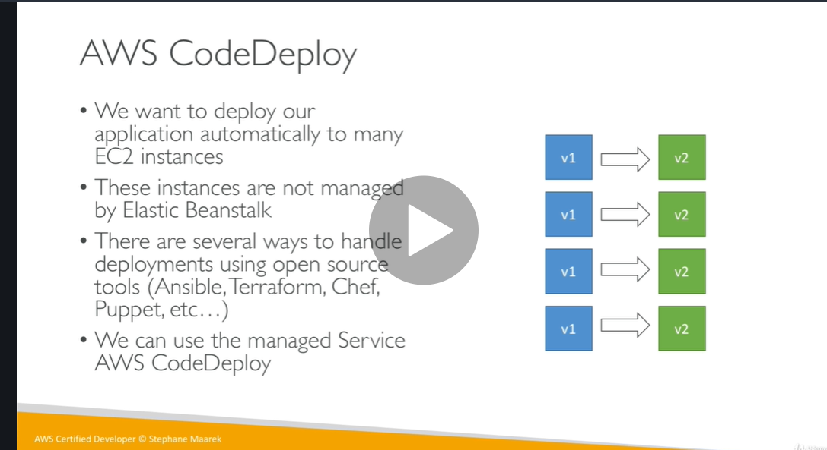

Code deploy flow diagram : nicely explained

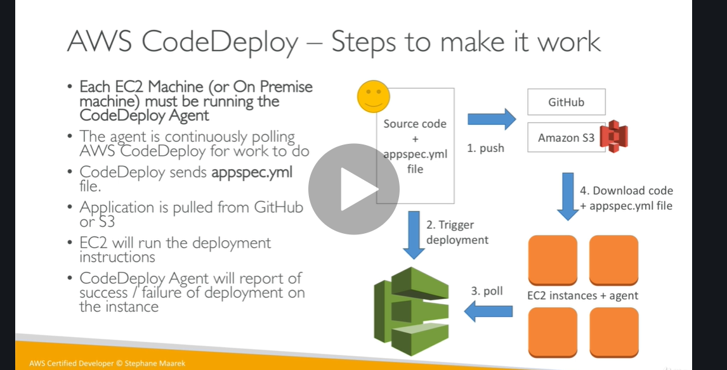

Note :

Codedeploy is more powerful than elastic beanstalk since elastic beanstalk force us to use it

Codedeploy assumes that ec2 instance are already existing

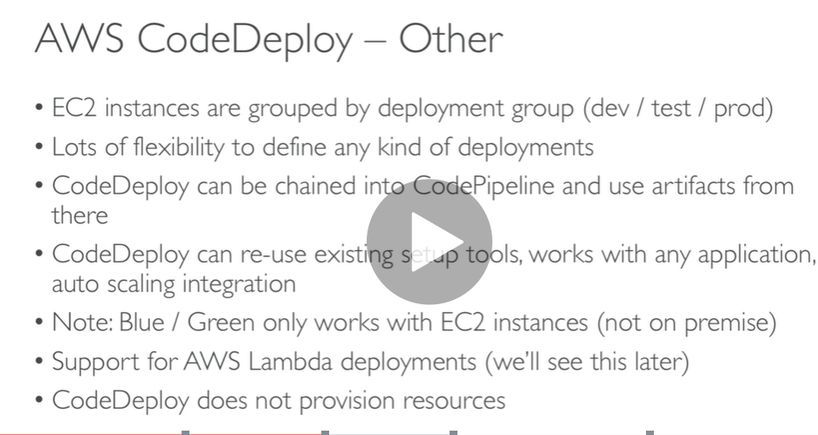

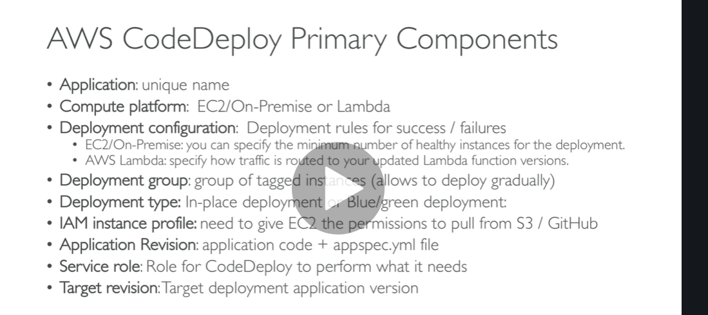

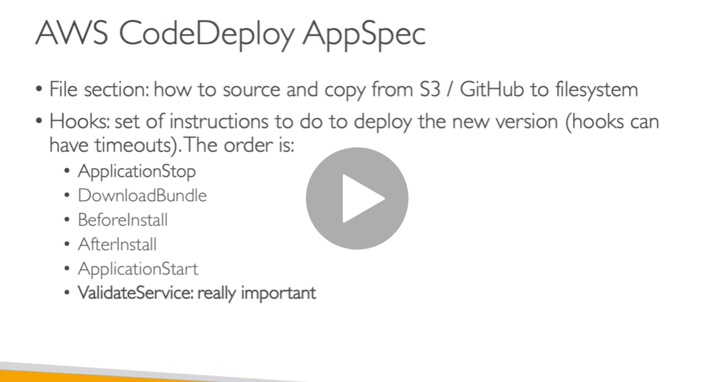

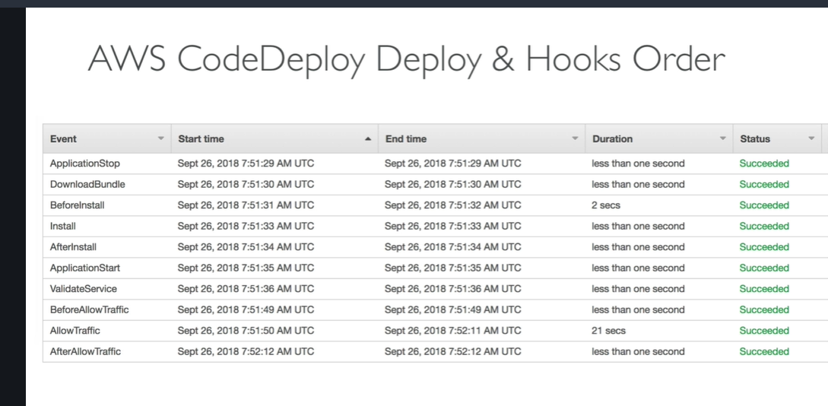

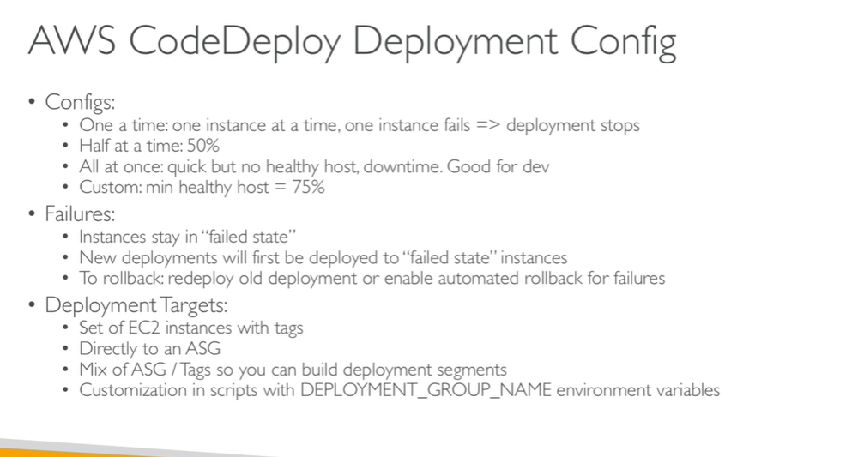

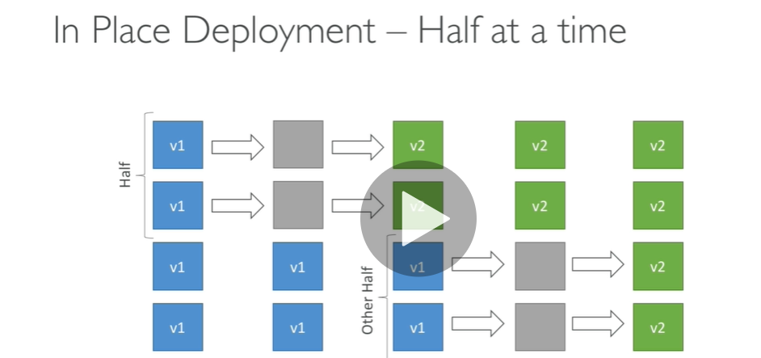

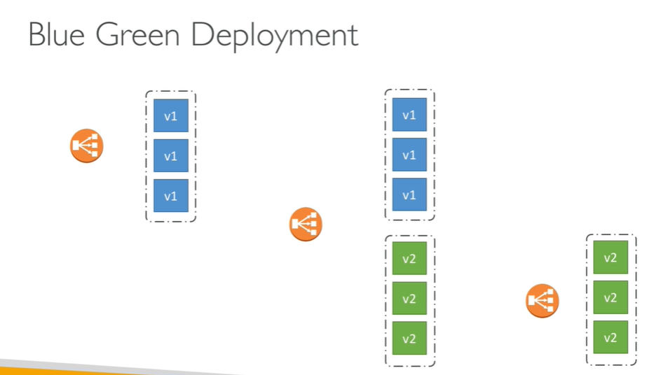

Code deploy Hands on

We need to create two role

* Codedeploy
* Ec2
* Create deployment group
* Upload file in s3
* Create deployment

Step 1**) create IAM role for code deploy : go to role in iam and click code deploy**

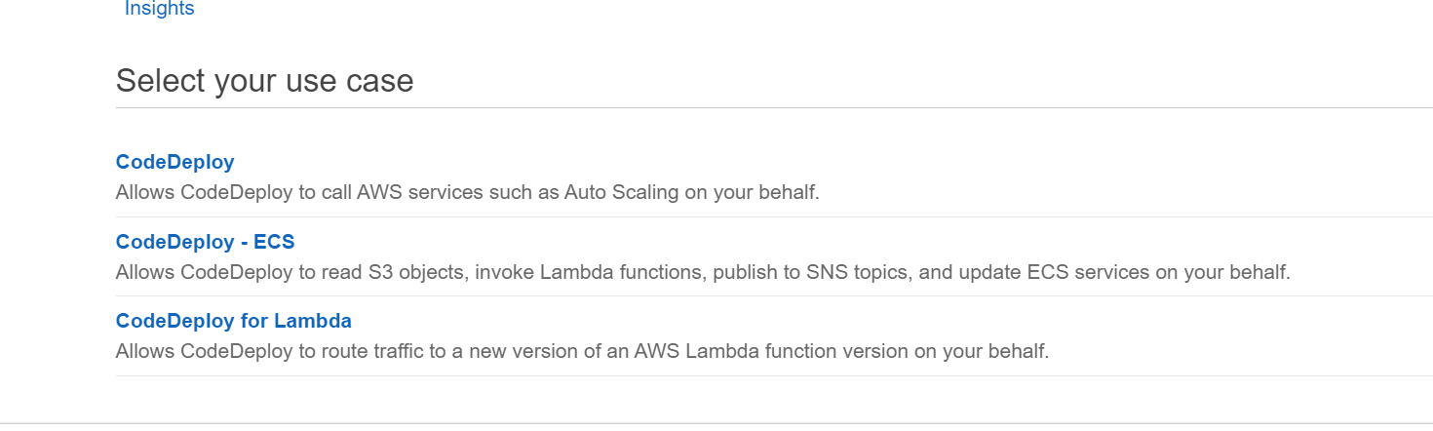

**Select first one we are doing ec2 code deployment**

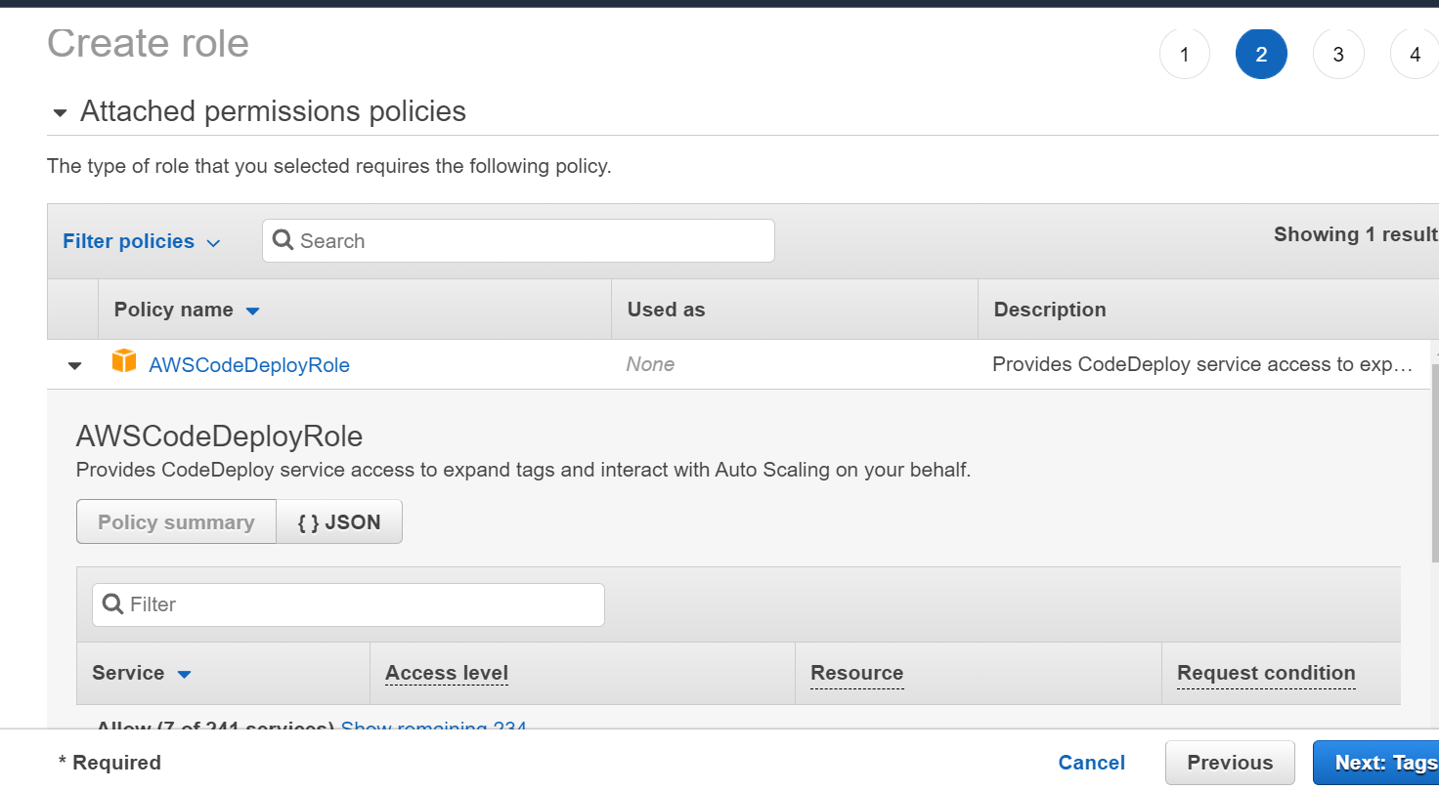

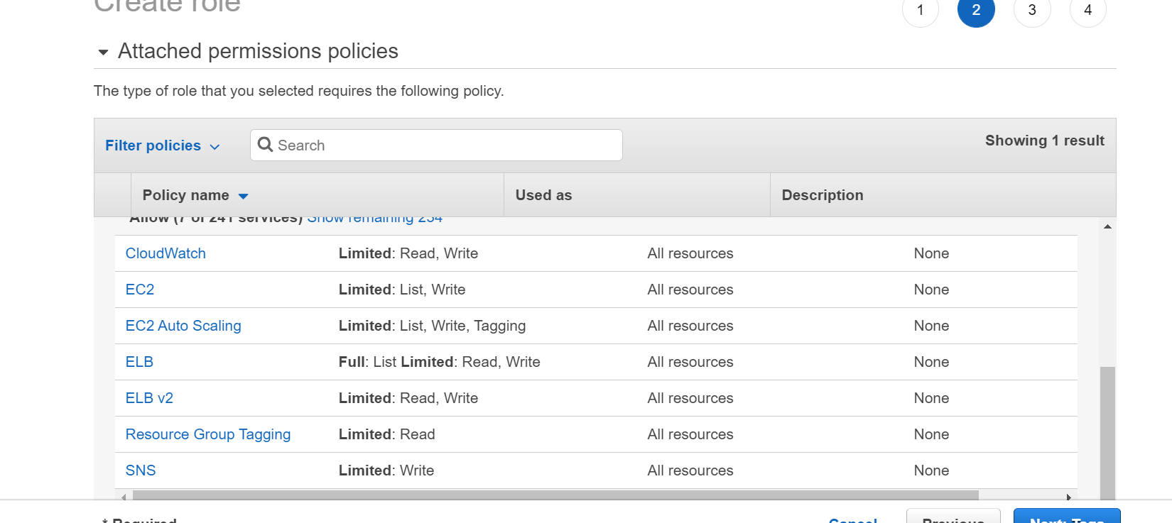

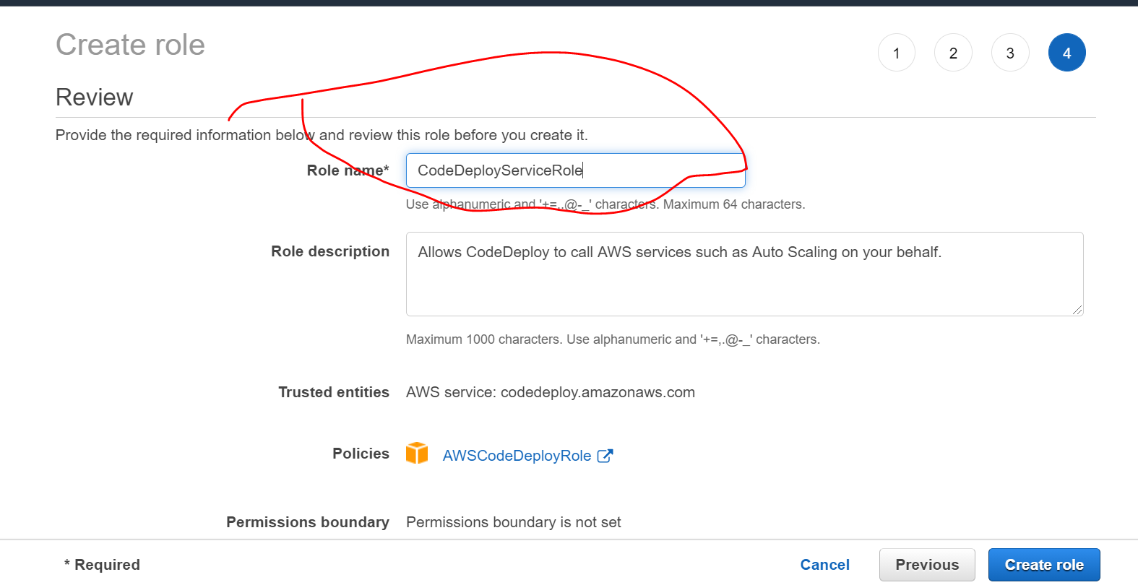

**2)ec2 role since it need to pull data from s3 so it need s3 access**

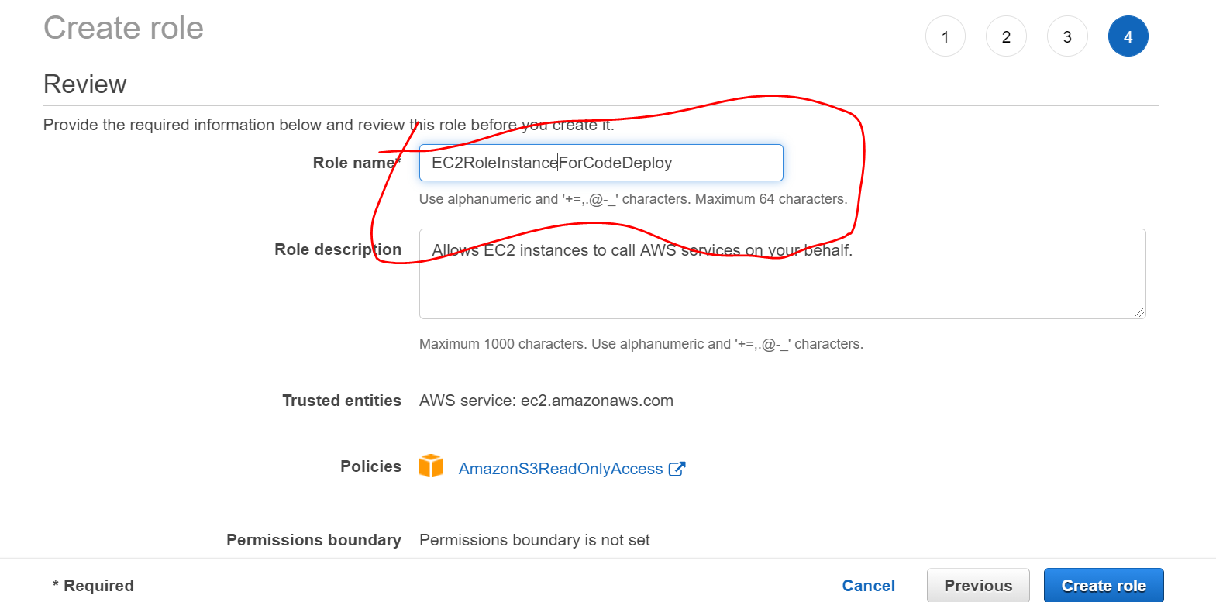

**Step 2) go to codedeploy**

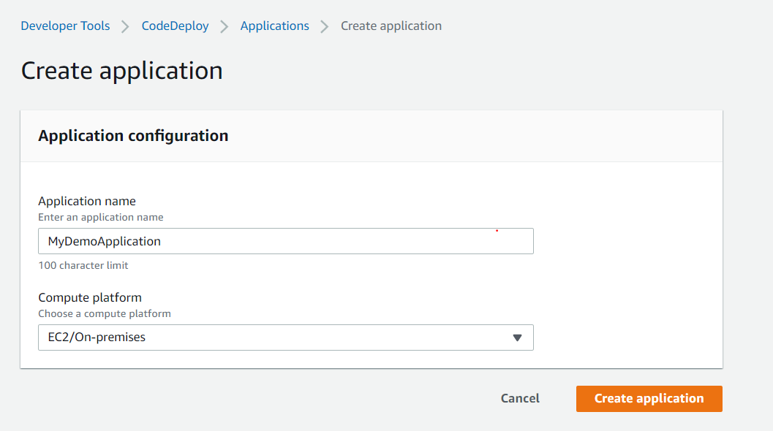

**Step 3 create deployment group**

**:**

**To do this first we need to create EC2 instance that we can deploy it**

**Add role ec2instance**

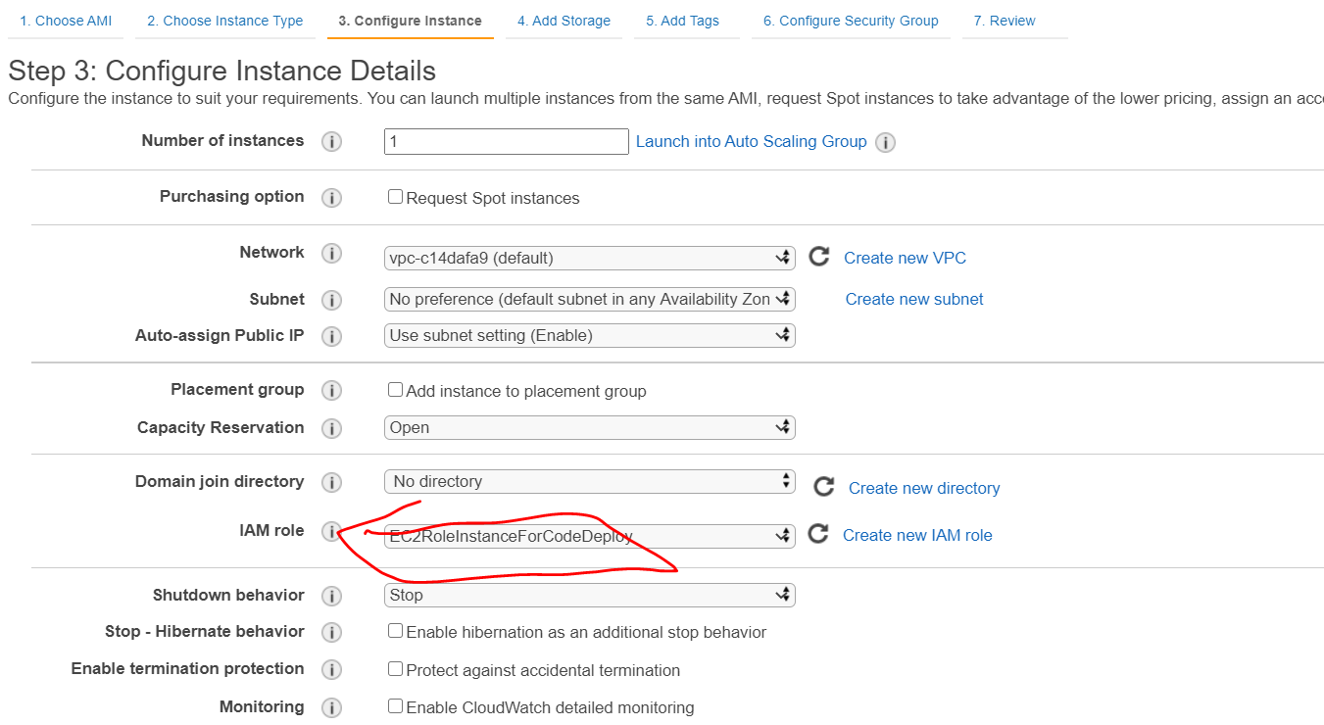

**Add http :**

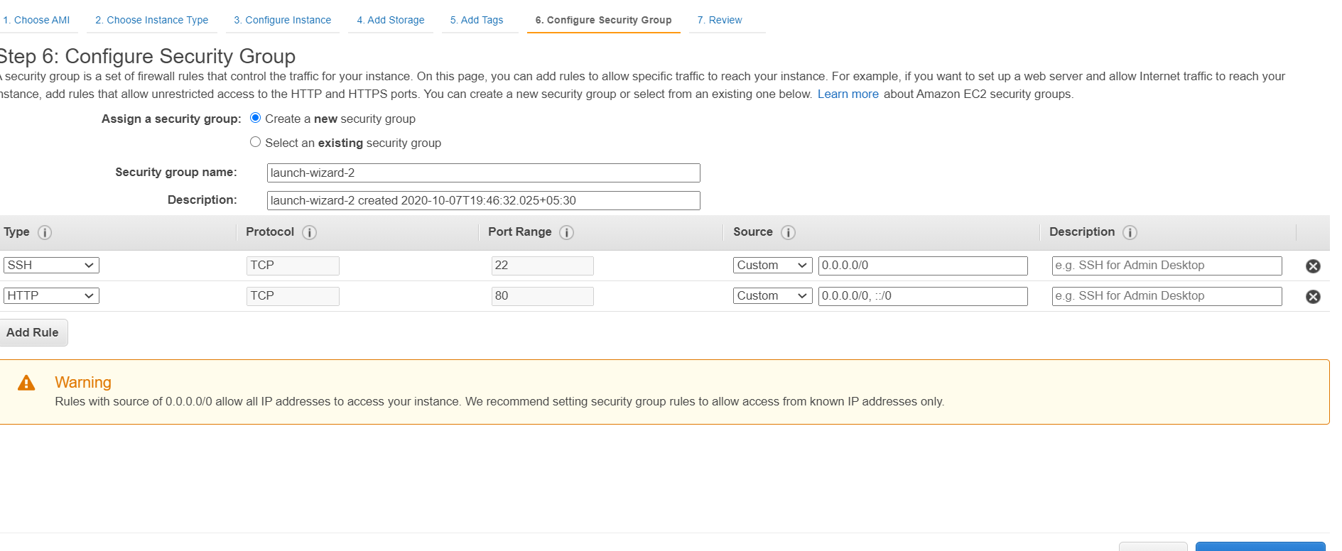

**Step 4) we need to deploy codedeploy agent in ec2 machine by default it don’t come**

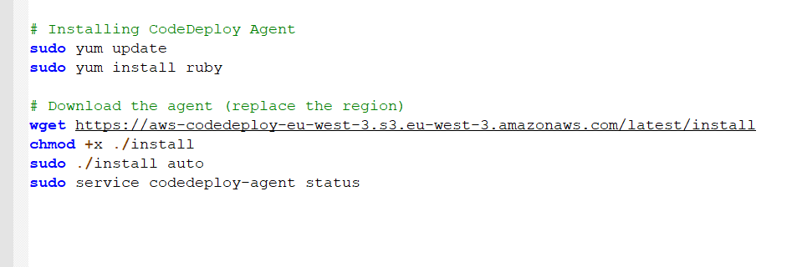

**After running aboue command from ec2 machine**



**Step 5) back to codedeploy :**

**Deployment group : are set of ec2 instance where we will deploy our application**

**That means we can define prod instance,development instance**

**Note to create a deployment group first we need to tag our ec2 instance**

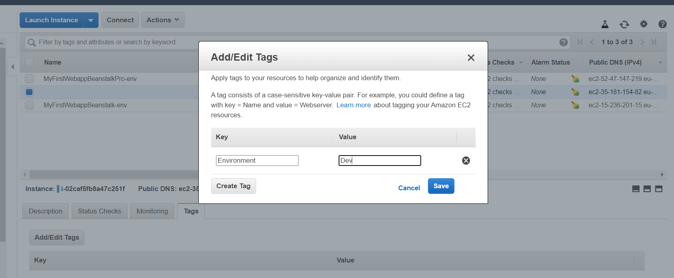

**This means code deploy agent is part of dev environment**

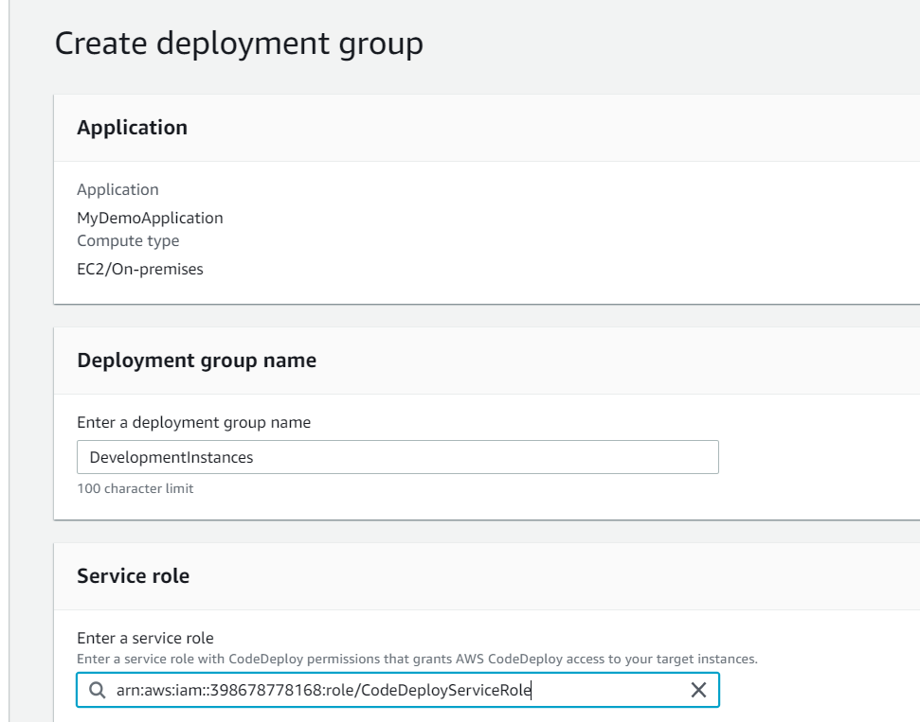

**By giving key and value in deployment group it will match all ec2 instance which we gave in ec2 tag**

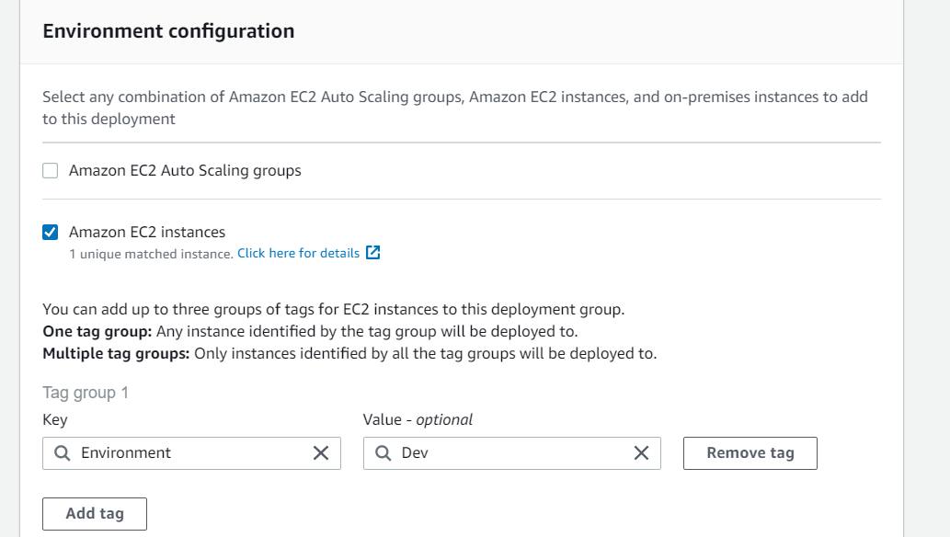

**Now deployment group is created click demo application**

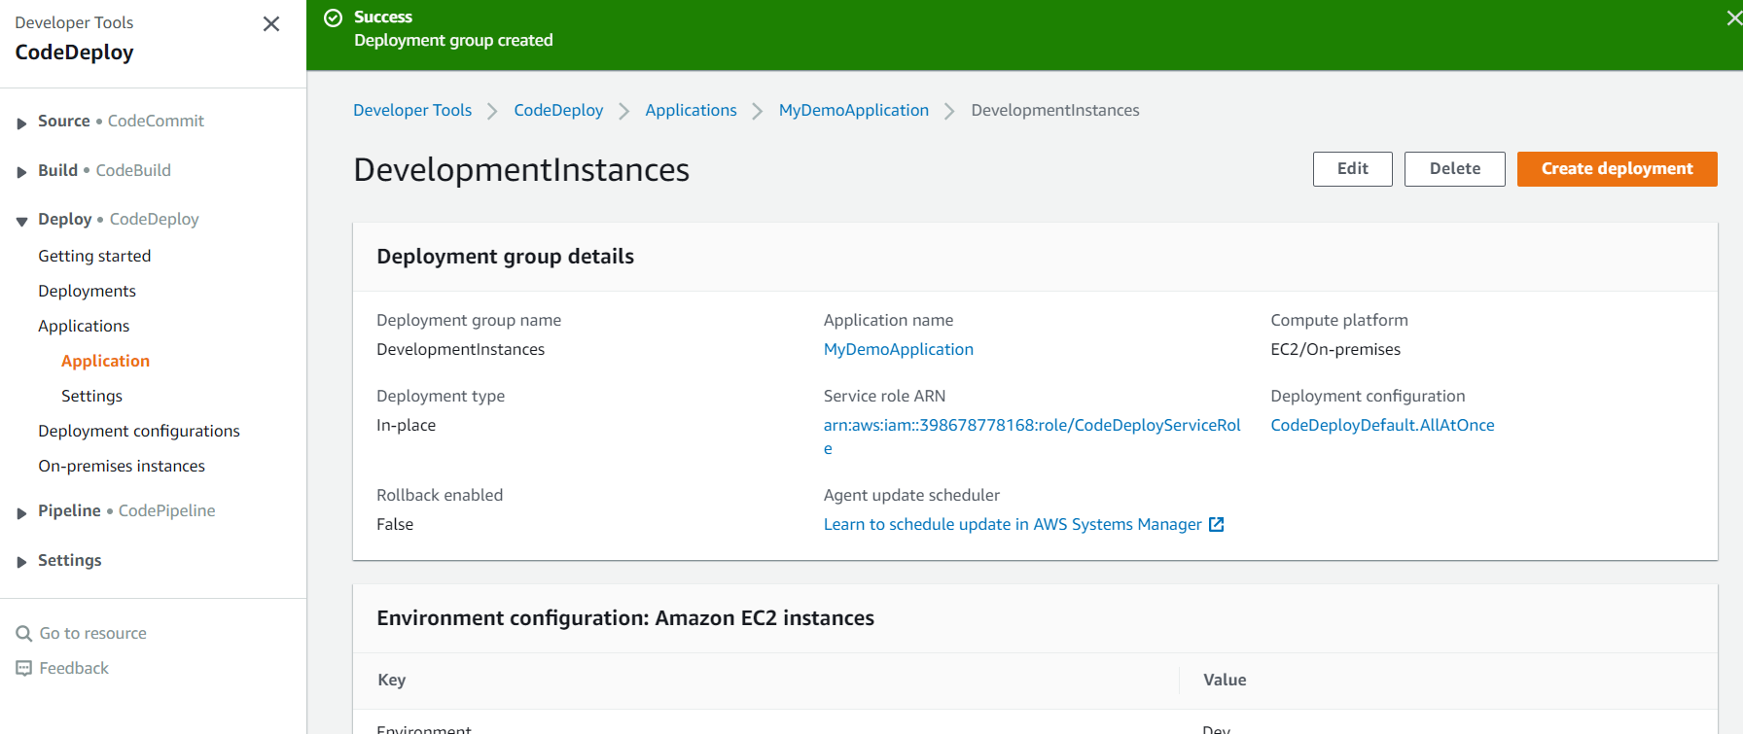

**Click deployment and create deployment**

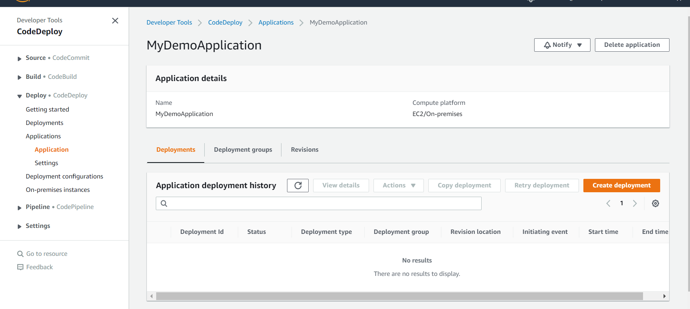

**Store application in s3**

**Appspec.yml help to understand codedeploy how to deploy application in ec2**

**Click copy path when code uploaded in s3**

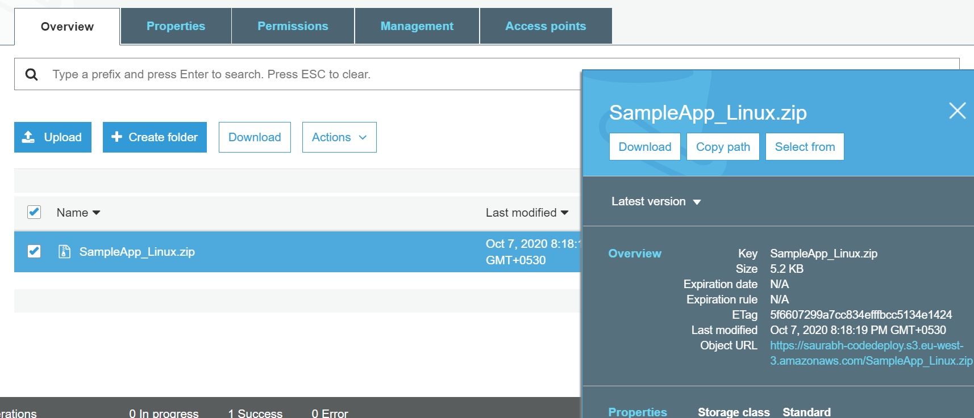

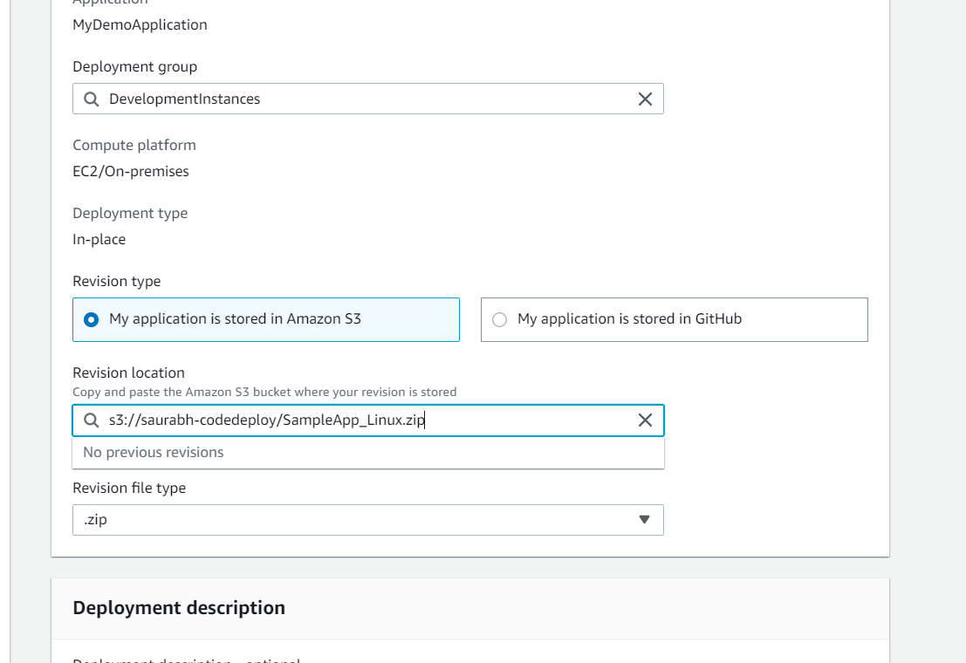

**Installing application on instances**

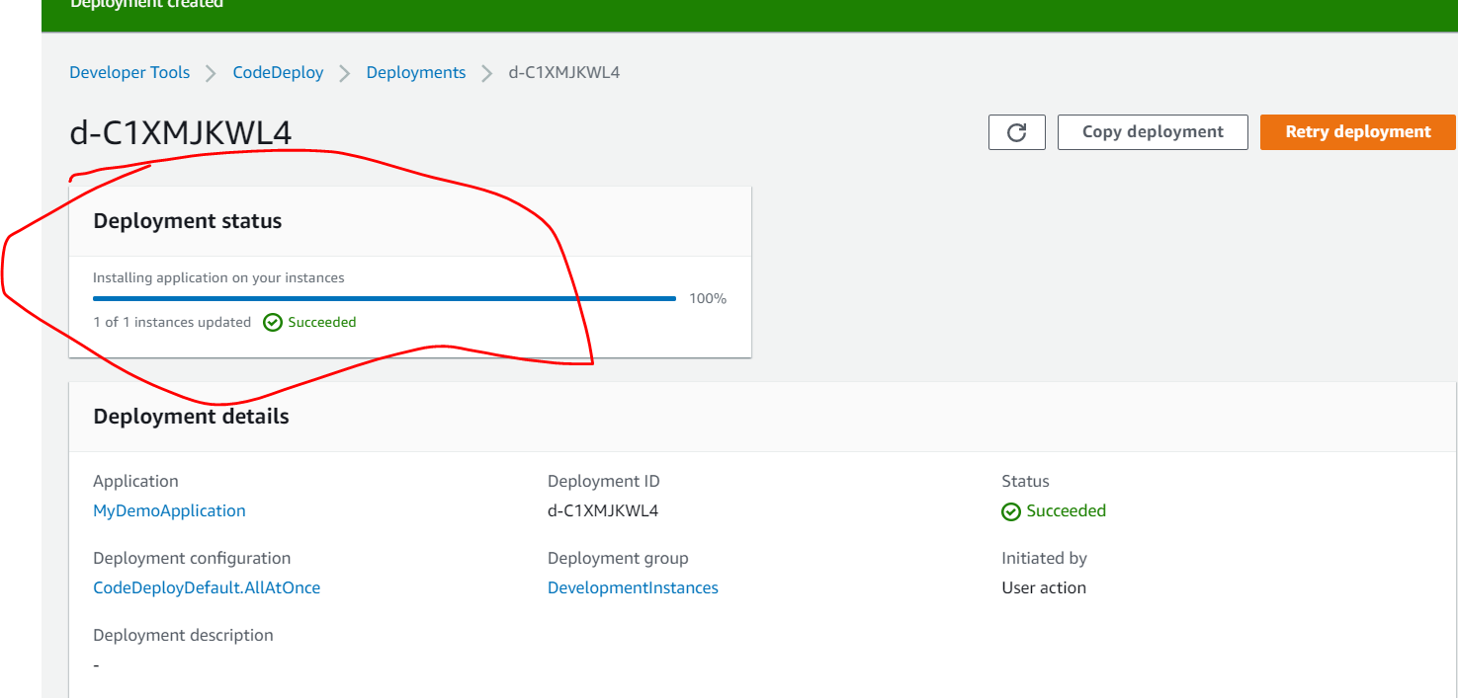

**We will get of details :**

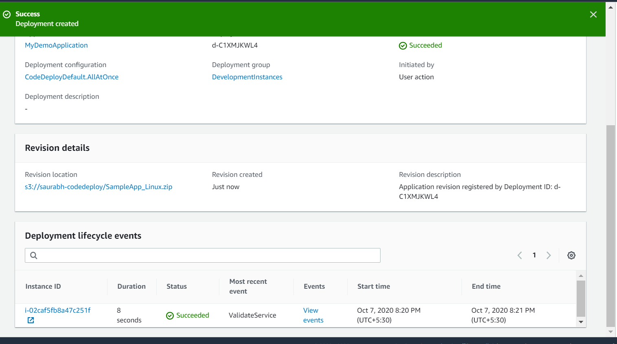

**Click on view event**

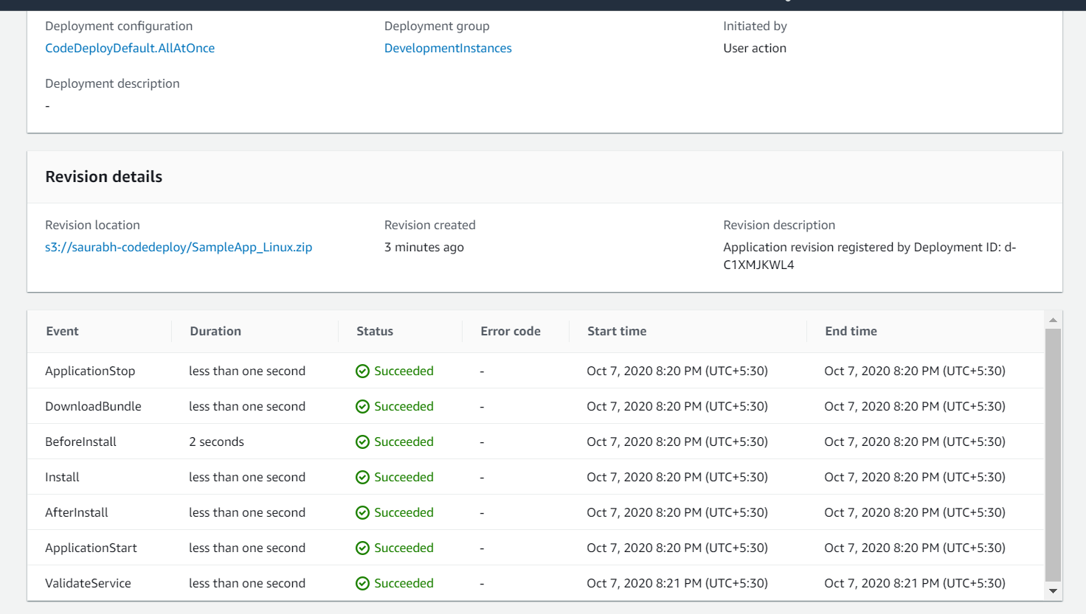

**Our application deployed using codedeploy**

